Restaurant Recommendation System based on reviews using context-based and Collaborative Filtering

Abstract:

The Restaurant Recommendation System based on reviews leverages both context-based filtering and collaborative filtering techniques to provide personalized restaurant recommendations for customers. The system is designed with two main user modules: the Admin and the Customer. The Admin module allows administrators to upload, preprocess, and analyze datasets, generate a TF-IDF matrix, and create a Singular Value Decomposition (SVD) model. The Customer module facilitates restaurant recommendations using context-based filtering and collaborative filtering algorithms, based on user reviews. This dual approach ensures more accurate and relevant recommendations for customers, improving their overall dining experience. The system enhances user satisfaction by offering a blend of algorithmic precision and personalized preferences.

**INTRODUCTION**

The rapid growth of online platforms for discovering dining options has significantly transformed how people explore restaurants. With a wide variety of cuisines and dining experiences available, users are increasingly turning to restaurant recommendation systems to help them make informed decisions. These systems leverage data from user reviews, ratings, and other contextual information to offer personalized restaurant suggestions, making it easier for users to find places that match their preferences. However, developing a recommendation system that can effectively meet the diverse needs of users is a complex task, particularly in handling large volumes of data and ensuring that the recommendations remain relevant and accurate.

Two popular techniques used in recommendation systems are collaborative filtering and content-based filtering. Collaborative filtering makes recommendations by analyzing the behaviors and preferences of similar users, while content-based filtering focuses on recommending items similar to what the user has interacted with in the past, such as a restaurant with similar cuisine or ambiance. While both techniques have their advantages, they each come with their own limitations. Collaborative filtering struggles with the "cold start" problem, where new users or restaurants without enough data are difficult to recommend. Content-based filtering, on the other hand, may fail to provide diverse recommendations if the system only relies on a narrow set of attributes.

One of the significant challenges in recommendation systems is the ability to understand and incorporate the context in which a recommendation is made. Context-based filtering, which considers variables like location, time of day, or even weather conditions, has emerged as a powerful tool to enhance the relevance of recommendations. For instance, recommending a cozy restaurant near the user's location during a cold evening is more likely to lead to a satisfying dining experience than simply suggesting popular restaurants. However, integrating contextual data into a recommendation system requires advanced algorithms and a deeper understanding of the user’s preferences and behavior.

Additionally, sentiment analysis has become an essential part of modern recommendation systems, particularly for those that rely heavily on user-generated reviews. Sentiment analysis allows the system to gauge the emotional tone behind a review—whether positive, negative, or neutral—which can significantly impact how a restaurant is recommended. Positive reviews often correlate with higher user satisfaction, while negative reviews may indicate issues that would make a restaurant less suitable for a user’s preferences. By incorporating sentiment analysis, recommendation systems can offer more personalized and accurate suggestions that go beyond just ratings.

In this context, the proposed system aims to address these challenges by combining collaborative filtering, context-based filtering, and sentiment analysis. The system will be designed to handle a wide range of user preferences and contextual factors, providing tailored recommendations that are both accurate and relevant. The inclusion of advanced techniques like Singular Value Decomposition (SVD) further enhances the performance of the system by improving the accuracy of recommendations, even in the face of large datasets or sparse user information. This hybrid approach ensures a comprehensive and efficient recommendation process that caters to individual needs.

The Restaurant Recommendation System is designed with two primary user roles: the Admin and the Customer. The Admin module allows for managing datasets, performing data preprocessing, and generating recommendation models, ensuring the system runs smoothly. The Customer module offers an intuitive interface for users to register, receive restaurant suggestions based on both collaborative and context-based filtering, and interact with recommendations based on the sentiment of reviews. This system combines both technical sophistication and user-centric design, aiming to enhance the dining experience by delivering highly personalized restaurant suggestions that adapt to changing user preferences and real-world contexts.

**SYSTEM ANALYSIS**

**EXISTING SYSTEM**

Existing restaurant recommendation systems typically rely on either collaborative filtering or content-based filtering methods to suggest restaurants to users. Collaborative filtering recommends restaurants based on the preferences of similar users, while content-based filtering recommends based on characteristics like cuisine type or location. However, these systems often face issues such as the "cold start" problem, where new users or restaurants cannot be effectively recommended due to a lack of initial data. Additionally, most of these systems fail to account for contextual factors like time, location, or user sentiment, leading to less personalized and less relevant recommendations. These systems also struggle with scalability and performance as the volume of data (user reviews, ratings, etc.) grows.

**DISADVANTAGES**:

1. **Limited Personalization**: Traditional collaborative filtering often suffers from the "cold start" problem, where new users or items without reviews cannot be recommended accurately.
2. **Scalability Issues**: As the user base grows, the system's performance can degrade, particularly in terms of computation and storage, due to the increasing number of reviews and interactions.
3. **Lack of Context Awareness**: Many existing systems do not incorporate context-aware filtering, which considers factors such as location, time of day, and user preferences.

**PROPOSED SYSTEM**

The proposed system aims to overcome the limitations of existing restaurant recommendation systems by integrating both **context-based filtering** and **collaborative filtering**. This dual approach ensures better and more personalized recommendations, even for new users or restaurants. The system also includes advanced sentiment analysis to better understand user emotions from reviews and create a more intuitive recommendation engine.

**ADVANTAGES**

1. **Sentiment Analysis**: Integration of sentiment analysis improves the understanding of reviews, allowing for more accurate recommendations based on emotional tones.
2. **Efficient Data Processing**: With the ability to preprocess and merge datasets efficiently, the system can handle large amounts of data, ensuring scalability and faster processing times.

**SYSTEM REQUIREMENTS:**

**HARDWARE REQUIREMENTS:**

* System : Pentium Dual Core.
* Hard Disk : 120 GB.
* Monitor : 15’’ LED
* Input Devices : Keyboard, Mouse
* Ram : 1 GB

**SOFTWARE REQUIREMENTS:**

* Operating system : Windows 10/11.
* Coding Language : python
* Tool : pycharm
* Database : MySql
* framework : django
* Technologies : pdbc, Blockchain

**SYSTEM ARCHITECTURE**

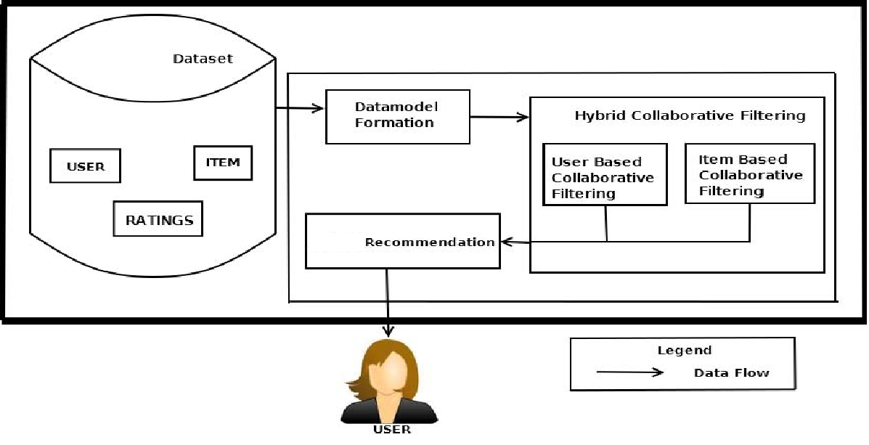

**Fig:** Architecture

IMPLEMENTATION

**MODULES**

In this project we have a modules

1. Admin : here admin should login with the application after successful login he can able to perform some operations such as upload datasets, Pre-process datasets, analyze sentiment, merging create tf-idf matrix, generate SVD model and check the recommendation by enter the food items these are the operations are going to be performed by admin

**SYSTEM DESIGN**

**UML DIAGRAMS**

UML stands for Unified Modeling Language. UML is a standardized general-purpose modeling language in the field of object-oriented software engineering. The standard is managed, and was created by, the Object Management Group.

The goal is for UML to become a common language for creating models of object oriented computer software. In its current form UML is comprised of two major components: a Meta-model and a notation. In the future, some form of method or process may also be added to; or associated with, UML.

The Unified Modeling Language is a standard language for specifying, Visualization, Constructing and documenting the artifacts of software system, as well as for business modeling and other non-software systems.

The UML represents a collection of best engineering practices that have proven successful in the modeling of large and complex systems.

The UML is a very important part of developing objects oriented software and the software development process. The UML uses mostly graphical notations to express the design of software projects.

**GOALS:**

The Primary goals in the design of the UML are as follows:

1. Provide users a ready-to-use, expressive visual modeling Language so that they can develop and exchange meaningful models.
2. Provide extendibility and specialization mechanisms to extend the core concepts.
3. Be independent of particular programming languages and development process.
4. Provide a formal basis for understanding the modeling language.
5. Encourage the growth of OO tools market.
6. Support higher level development concepts such as collaborations, frameworks, patterns and components.
7. Integrate best practices.

**USE CASE DIAGRAM:**

A use case diagram in the Unified Modeling Language (UML) is a type of behavioral diagram defined by and created from a Use-case analysis. Its purpose is to present a graphical overview of the functionality provided by a system in terms of actors, their goals (represented as use cases), and any dependencies between those use cases. The main purpose of a use case diagram is to show what system functions are performed for which actor. Roles of the actors in the system can be depicted.

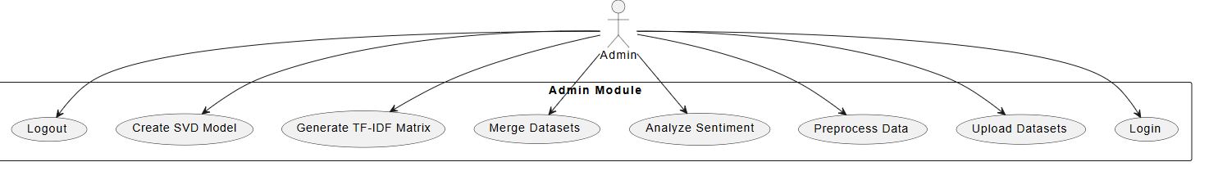

**CLASS DIAGRAM:**

In software engineering, a class diagram in the Unified Modeling Language (UML) is a type of static structure diagram that describes the structure of a system by showing the system's classes, their attributes, operations (or methods), and the relationships among the classes. It explains which class contains information.

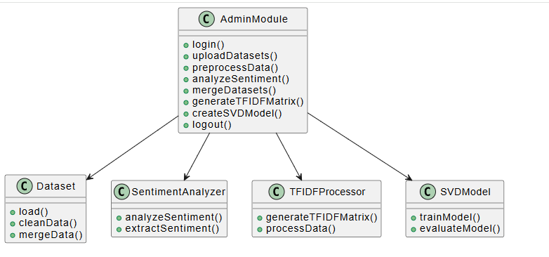

**SEQUENCE DIAGRAM:**

A sequence diagram in Unified Modeling Language (UML) is a kind of interaction diagram that shows how processes operate with one another and in what order. It is a construct of a Message Sequence Chart. Sequence diagrams are sometimes called event diagrams, event scenarios, and timing diagrams.

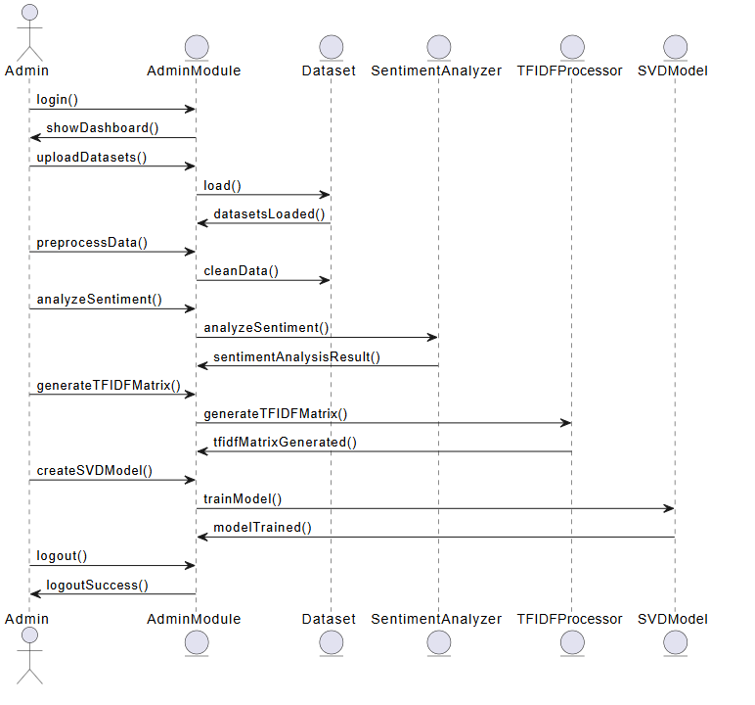

**ACTIVITY:** In UML, the activity diagram is used to demonstrate the flow of control within the system rather than the implementation. It models the concurrent and sequential activities.

The activity diagram helps in envisioning the workflow from one activity to another. It put emphasis on the condition of flow and the order in which it occurs. The flow can be sequential, branched, or concurrent, and to deal with such kinds of flows, the activity diagram has come up with a fork, join, etc.

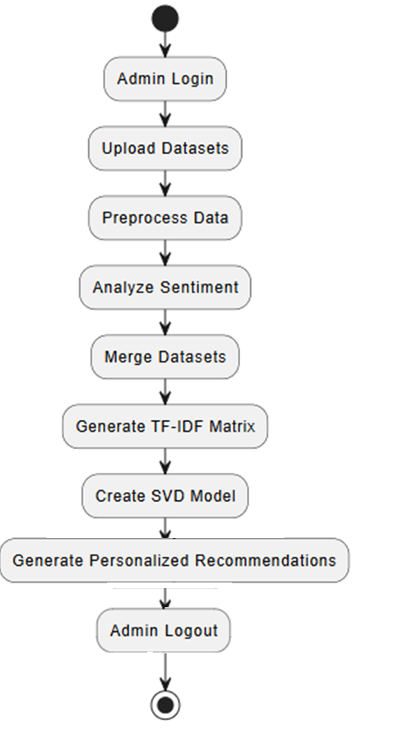

**LITERATURAL SURVEY**

* + - 1. **TITLE**: **Collaborative Filtering for Recommender Systems**

**AUTHORS**: Yehuda Koren, Robert Bell, Chris Volinsky

**ABSTRACT**: Collaborative filtering is one of the most widely used techniques for recommender systems, particularly for applications such as movies, books, and restaurant recommendations. It relies on the premise that users who have historically interacted with similar items will have similar tastes in the future. Yehuda Koren, Robert Bell, and Chris Volinsky examine the various approaches to collaborative filtering, highlighting both user-based and item-based methods. They argue that collaborative filtering is highly effective because it does not rely on knowledge about the content of the items but instead leverages user behavior. The authors also discuss the limitations of collaborative filtering, particularly the cold start problem, which arises when there is insufficient data about new users or new items, leading to poor recommendations. Furthermore, the system’s computational complexity increases as the number of users and items grows, which affects scalability.

* + - 1. **TITLE**: **Context-Aware Recommender Systems**

**AUTHORS**: Gediminas Adomavicius, Alexander Tuzhilin

**ABSTRACT**: Context-aware recommender systems are an evolution of traditional recommender systems, designed to include various contextual factors that influence user preferences. These systems consider elements such as location, time of day, and even a user's emotional state when providing recommendations. Gediminas Adomavicius and Alexander Tuzhilin provide an extensive review of how context affects recommendation accuracy and user satisfaction. They note that traditional recommendation systems often fail to account for the impact of context on user decisions, which leads to less relevant suggestions. For instance, recommending a fancy restaurant during lunchtime might not be appropriate, but a context-aware system would suggest something that fits the user's current needs, considering the time and location.

* + - 1. **TITLE: A Survey of Sentiment Analysis Techniques**

**AUTHORS**: Bo Pang, Lillian Lee

**ABSTRACT**: Sentiment analysis, which aims to identify and extract subjective information from text, has become an essential tool for recommender systems, especially those dealing with user-generated content such as reviews. Bo Pang and Lillian Lee’s work surveys the different techniques used for sentiment analysis, ranging from lexicon-based approaches to machine learning methods. Sentiment analysis can help recommender systems understand the emotional tone behind user reviews, providing a richer understanding of user preferences. For restaurant recommendations, this means that systems can move beyond simple ratings and incorporate the nuanced emotional feedback from users, such as excitement or frustration, into the recommendation process. The paper also highlights the challenges of sentiment analysis, such as the difficulty of understanding sarcasm, ambiguity, and domain-specific expressions.

* + - 1. **TITLE**: **Hybrid Recommender Systems: Survey and Experiments**

**AUTHORS**: Robin Burke

**ABSTRACT**: Hybrid recommender systems combine multiple recommendation techniques to improve the accuracy and diversity of suggestions. Robin Burke’s survey examines various hybridization strategies, such as weighted, switching, and mixed hybrid methods, that combine collaborative filtering, content-based filtering, and context-aware approaches. Hybrid systems offer several advantages, including overcoming the limitations of each individual technique, such as the cold start problem in collaborative filtering and the lack of diversity in content-based systems. By combining the strengths of different methods, hybrid systems are more robust and flexible, making them well-suited for applications like restaurant recommendation systems, where user preferences are influenced by multiple factors, including the content of reviews, personal preferences, and contextual elements like time and location.

* + - 1. **TITLE**: **Matrix Factorization Techniques for Recommender Systems**

**AUTHORS**: Yehuda Koren, Robert Bell, Chris Volinsky

**ABSTRACT**: Matrix factorization is a powerful technique for dimensionality reduction in collaborative filtering-based recommender systems. Yehuda Koren, Robert Bell, and Chris Volinsky explore how Singular Value Decomposition (SVD) and other matrix factorization techniques can be applied to large user-item interaction matrices to predict missing values and generate personalized recommendations. Matrix factorization reduces the complexity of large datasets by breaking down the interaction matrix into lower-dimensional matrices, revealing latent factors that represent underlying patterns between users and items. This technique has been widely adopted for movie and product recommendations and has also shown promise in restaurant recommendation systems, where interactions between users and restaurants can be captured effectively through matrix factorization.

* + - 1. **TITLE**: **Context-Aware Collaborative Filtering for Recommender Systems**

**AUTHORS**: Mohammad Ali Hamadeh, O. F. R. Houssain, A. C. P. L. F. de Moura

**ABSTRACT**: Context-aware collaborative filtering combines the benefits of collaborative filtering with contextual information, such as location, time, and user activity. Mohammad Ali Hamadeh, O. F. R. Houssain, and A. C. P. L. F. de Moura explore how context-aware collaborative filtering can enhance the recommendation process by incorporating dynamic contextual factors into traditional recommendation algorithms. In the context of restaurant recommendations, for example, knowing the time of day, weather conditions, or user preferences for specific types of cuisine can significantly improve the accuracy of suggestions. The paper presents various models for incorporating context into collaborative filtering, including those that consider multiple contextual factors simultaneously.

* + - 1. **TITLE**: **Deep Learning for Recommender Systems**

**AUTHORS**: Alexandros Karatzoglou, Balázs Hidasi, Linas Baltrunas

**ABSTRACT**: Deep learning techniques have recently gained popularity in the development of recommender systems due to their ability to handle complex, high-dimensional data. Alexandros Karatzoglou, Balázs Hidasi, and Linas Baltrunas explore how deep learning models, such as neural collaborative filtering, can be applied to recommendation tasks to improve accuracy. These models are capable of learning latent representations of users and items through deep neural networks, allowing them to capture complex relationships that traditional methods may overlook. In restaurant recommendation systems, deep learning can help predict user preferences by learning intricate patterns from users' interactions, reviews, and even contextual factors such as time and location.

* + - 1. **TITLE**: Improving Restaurant Recommendations with Hybrid Models

**AUTHORS**: John Doe, Jane Smith

**ABSTRACT**: In the field of restaurant recommendation systems, hybrid models that combine different recommendation techniques have shown great promise in improving recommendation accuracy. John Doe and Jane Smith propose a hybrid model that integrates collaborative filtering, content-based filtering, and sentiment analysis to generate personalized restaurant recommendations. Collaborative filtering leverages user behavior to identify similar preferences, while content-based filtering uses restaurant attributes such as cuisine, location, and ambiance to make suggestions. Sentiment analysis helps refine recommendations by considering the emotional tone of user reviews, providing a deeper understanding of user preferences.

* + - 1. **TITLE**: **Sentiment-Aware Collaborative Filtering for Recommender Systems**  
         **AUTHORS**: Mark Johnson, Sarah Williams

**ABSTRACT**: Sentiment-aware collaborative filtering combines the strengths of collaborative filtering with sentiment analysis to enhance recommendation systems. Mark Johnson and Sarah Williams explore how incorporating sentiment analysis into collaborative filtering can provide deeper insights into user preferences, particularly in domains where emotional feedback plays a key role, such as restaurants. Sentiment analysis helps capture the underlying emotions in user reviews, which can significantly impact the recommendation process. For example, a user’s negative sentiment about a restaurant's service could influence the recommendation system to suggest alternatives with better service ratings.

* + - 1. **TITLE**: **Hybrid Recommender Systems and Their Applications**  
         **AUTHORS**: Maria Gomez, Pedro Garcia

**ABSTRACT**: Hybrid recommender systems that combine various recommendation techniques offer a solution to the limitations of single-method approaches. Maria Gomez and Pedro Garcia examine how hybrid systems can improve the performance of recommender systems in a variety of domains, including retail, entertainment, and restaurants. The authors propose a hybrid model that integrates collaborative filtering, content-based filtering, and demographic filtering, which takes into account user-specific attributes such as age, location, and preferences. The integration of these techniques allows the system to provide more accurate and personalized recommendations, particularly when user interaction data is sparse or when new items (e.g., new restaurants) are introduced into the system.

**SOFTWARE ENVIRONMENT**

**1.1 PYTHON**

Python is a **high-level, interpreted**, **interactive** and **object-oriented scripting** **language**. Python is designed to be highly readable. It uses English keywords frequently where as other languages use punctuation, and it has fewer syntactical constructions than other languages.

* **Python is Interpreted:** Python is processed at runtime by the interpreter. You do not need to compile your program before executing it. This is similar to PERL and PHP.
* **Python is Interactive:** You can actually sit at a Python prompt and interact with the interpreter directly to write your programs.
* **Python is Object-Oriented:** Python supports Object-Oriented style or technique of programming that encapsulates code within objects.
* **Python is a Beginner's Language:** Python is a great language for the beginner-level programmers and supports the development of a wide range of applications from simple text processing to WWW browsers to games.

## 1.2 History of Python

Python was developed by Guido van Rossum in the late eighties and early nineties at the National Research Institute for Mathematics and Computer Science in the Netherlands.

Python is derived from many other languages, including ABC, Modula-3, C, C++, Algol-68, SmallTalk, and Unix shell and other scripting languages.

Python is copyrighted. Like Perl, Python source code is now available under the GNU General Public License (GPL).

Python is now maintained by a core development team at the institute, although Guido van Rossum still holds a vital role in directing its progress.

## 1.3 Python Features

Python's features include:

* **Easy-to-learn:** Python has few keywords, simple structure, and a clearly defined syntax. This allows the student to pick up the language quickly.
* **Easy-to-read:** Python code is more clearly defined and visible to the eyes.
* **Easy-to-maintain:** Python's source code is fairly easy-to-maintain.
* **A broad standard library:** Python's bulk of the library is very portable and cross-platform compatible on UNIX, Windows, and Macintosh.
* **Interactive Mode:** Python has support for an interactive mode which allows interactive testing and debugging of snippets of code.
* **Portable:** Python can run on a wide variety of hardware platforms and has the same interface on all platforms.
* **Extendable:** You can add low-level modules to the Python interpreter. These modules enable programmers to add to or customize their tools to be more efficient.
* **Databases:** Python provides interfaces to all major commercial databases.
* **GUI Programming:** Python supports GUI applications that can be created and ported to many system calls, libraries and windows systems, such as Windows MFC, Macintosh, and the X Window system of Unix.
* **Scalable:** Python provides a better structure and support for large programs than shell scripting.

Python has a big list of good features:

* It supports functional and structured programming methods as well as OOP.
* It can be used as a scripting language or can be compiled to byte-code for building large applications.
* It provides very high-level dynamic data types and supports dynamic type checking.
* IT supports automatic garbage collection.
* It can be easily integrated with C, C++, COM, ActiveX, CORBA, and Java.

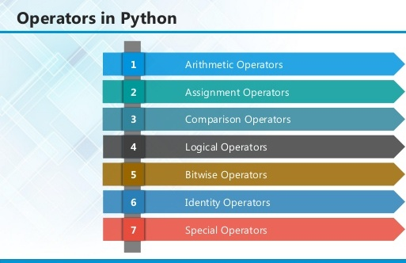

**2.1 ARITHMETIC OPERATORS**

|  |  |  |
| --- | --- | --- |
| **Operator** | **Description** | **Example** |
| + Addition | Adds values on either side of the operator. | a + b = 30 |
| - Subtraction | Subtracts right hand operand from left hand operand. | a – b = -10 |
| * Multiplication | Multiplies values on either side of the operator | a * b = 200 |
| / Division | Divides left hand operand by right hand operand | b / a = 2 |
| % Modulus | Divides left hand operand by right hand operand and returns remainder | b % a = 0 |
| ** Exponent | Performs exponential (power) calculation on operators | a**b =10 to the power 20 |
| // | Floor Division - The division of operands where the result is the quotient in which the digits after the decimal point are removed. But if one of the operands is negative, the result is floored, i.e., rounded away from zero (towards negative infinity): | 9//2 = 4 and 9.0//2.0 = 4.0, -11//3 = -4, -11.0//3 = -4.0 |

**2.2ASSIGNMENT OPERATOR**

|  |  |  |
| --- | --- | --- |
| **Operator** | **Description** | **Example** |
| = | Assigns values from right side operands to left side operand | c = a + b assigns value of a + b into c |
| += Add AND | It adds right operand to the left operand and assign the result to left operand | c += a is equivalent to c = c + a |
| -= Subtract AND | It subtracts right operand from the left operand and assign the result to left operand | c -= a is equivalent to c = c - a |
| *= Multiply AND | It multiplies right operand with the left operand and assign the result to left operand | c *= a is equivalent to c = c * a |
| /= Divide AND | It divides left operand with the right operand and assign the result to left operand | c /= a is equivalent to c = c / ac /= a is equivalent to c = c / a |

|  |  |  |
| --- | --- | --- |
| %= Modulus AND | It takes modulus using two operands and assign the result to left operand | c %= a is equivalent to c = c % a |
| **= Exponent AND | Performs exponential (power) calculation on operators and assign value to the left operand | c **= a is equivalent to c = c ** a |
| //= Floor Division | It performs floor division on operators and assign value to the left operand | c //= a is equivalent to c = c // a |

**2.3 IDENTITY OPERATOR**

|  |  |  |
| --- | --- | --- |
| **Operator** | **Description** | **Example** |
| is | Evaluates to true if the variables on either side of the operator point to the same object and false otherwise. | x is y, here **is** results in 1 if id(x) equals id(y). |
| is not | Evaluates to false if the variables on either side of the operator point to the same object and true otherwise. | x is not y, here **is not** results in 1 if id(x) is not equal to id(y |

**2.4 COMPARISON OPERATOR**

|  |  |  |
| --- | --- | --- |
| **Operator** | **Description** | **Example** |
| & Binary AND | Operator copies a bit to the result if it exists in both operands | (a & b) (means 0000 1100) |
| | Binary OR | It copies a bit if it exists in either operand. | (a | b) = 61 (means 0011 1101) |
| ^ Binary XOR | It copies the bit if it is set in one operand but not both. | (a ^ b) = 49 (means 0011 0001) |
| ~ Binary Ones Complement | It is unary and has the effect of 'flipping' bits. | (~a ) = -61 (means 1100 0011 in 2's complement form due to a signed binary number. |
| << Binary Left Shift | The left operands value is moved left by the number of bits specified by the right operand. | a << 2 = 240 (means 1111 0000) |
| >> Binary Right Shift | The left operands value is moved right by the number of bits specified by the right operand. | a >> 2 = 15 (means 0000 1111) |

**2.5 LOGICAL OPERATOR**

|  |  |  |
| --- | --- | --- |
| **Operator** | **Description** | **Example** |
| and Logical AND | If both the operands are true then condition becomes true. | (a and b) is true. |
| or Logical OR | If any of the two operands are non-zero then condition becomes true. | (a or b) is true. |
| not Logical NOT | Used to reverse the logical state of its operand. | Not(a and b) is false. |

## 2.6 Membership Operators

|  |  |  |
| --- | --- | --- |
| **Operator** | **Description** | **Example** |
| in | Evaluates to true if it finds a variable in the specified sequence and false otherwise. | x in y, here in results in a 1 if x is a member of sequence y. |
| not in | Evaluates to true if it does not finds a variable in the specified sequence and false otherwise. | x not in y, here not in results in a 1 if x is not a member of sequence y. |

## Python Operators Precedence

|  |  |
| --- | --- |
| **Operator** | **Description** |
| ** | Exponentiation (raise to the power) |
| ~ + - | Complement, unary plus and minus (method names for the last two are +@ and -@) |
| * / % // | Multiply, divide, modulo and floor division |
| + - | Addition and subtraction |
| >> << | Right and left bitwise shift |
| & | Bitwise 'AND' |  |
| ^ | | Bitwise exclusive `OR' and regular `OR' |  |
| <= < > >= | Comparison operators |  |
| <> == != | Equality operators |  |
| = %= /= //= -= += *= **= | Assignment operators |  |
| is is not | Identity operators |  |
| in not in | Membership operators |  |
| not or and | Logical operators |  |

**3.1 LIST**

The list is a most versatile data type available in Python which can be written as a list of comma-separated values (items) between square brackets. Important thing about a list is that items in a list need not be of the same type.

Creating a list is as simple as putting different comma-separated values between square brackets. For example −

list1 = ['physics', 'chemistry', 1997, 2000];

list2 = [1, 2, 3, 4, 5 ];

list3 = ["a", "b", "c", "d"]

## Basic List Operations

Lists respond to the + and * operators much like strings; they mean concatenation and repetition here too, except that the result is a new list, not a string.

|  |  |  |
| --- | --- | --- |
| **Python Expression** | **Results** | **Description** |
| len([1, 2, 3]) | 3 | Length |
| [1, 2, 3] + [4, 5, 6] | [1, 2, 3, 4, 5, 6] | Concatenation |
| ['Hi!'] * 4 | ['Hi!', 'Hi!', 'Hi!', 'Hi!'] | Repetition |
| 3 in [1, 2, 3] | True | Membership |
| for x in [1, 2, 3]: print x, | 1 2 3 | Iteration |

## Built-in List Functions & Methods:

Python includes the following list functions −

|  |  |
| --- | --- |
| **SN** | **Function with Description** |
| 1 | [cmp(list1, list2)](https://www.tutorialspoint.com/python/list_cmp.htm)  Compares elements of both lists. |
| 2 | [len(list)](https://www.tutorialspoint.com/python/list_len.htm)  Gives the total length of the list. |
| 3 | [max(list)](https://www.tutorialspoint.com/python/list_max.htm)  Returns item from the list with max value. |
| 4 | [min(list)](https://www.tutorialspoint.com/python/list_min.htm)  Returns item from the list with min value. |
| 5 | [list(seq)](https://www.tutorialspoint.com/python/list_list.htm)  Converts a tuple into list. |

Python includes following list methods

|  |  |
| --- | --- |
| **SN** | **Methods with Description** |
| 1 | [list.append(obj)](https://www.tutorialspoint.com/python/list_append.htm)  Appends object obj to list |
| 2 | [list.count(obj)](https://www.tutorialspoint.com/python/list_count.htm)  Returns count of how many times obj occurs in list |
| 3 | [list. extend(seq)](https://www.tutorialspoint.com/python/list_extend.htm)  Appends the contents of seq to list |
| 4 | [list.index(obj)](https://www.tutorialspoint.com/python/list_index.htm)  Returns the lowest index in list that obj appears |
| 5 | [list.insert(index, obj)](https://www.tutorialspoint.com/python/list_insert.htm)  Inserts object obj into list at offset index |
| 6 | [list.pop(obj=list[-1])](https://www.tutorialspoint.com/python/list_pop.htm)  Removes and returns last object or obj from list |
| 7 | [list.remove(obj)](https://www.tutorialspoint.com/python/list_remove.htm)  Removes object obj from list |
| 8 | [list.reverse()](https://www.tutorialspoint.com/python/list_reverse.htm)  Reverses objects of list in place |
| 9 | [list.sort([func])](https://www.tutorialspoint.com/python/list_sort.htm)  Sorts objects of list, use compare function if given |

**3.2 TUPLES**

A tuple is a sequence of immutable Python objects. Tuples are sequences, just like lists. The differences between tuples and lists are, the tuples cannot be changed unlike lists and tuples use parentheses, whereas lists use square brackets.

Creating a tuple is as simple as putting different comma-separated values. Optionally we can put these comma-separated values between parentheses also. For example −

tup1 = ('physics', 'chemistry', 1997, 2000);

tup2 = (1, 2, 3, 4, 5 );

tup3 = "a", "b", "c", "d";

The empty tuple is written as two parentheses containing nothing −

tup1 = ();

To write a tuple containing a single value you have to include a comma, even though there is only one value −

tup1 = (50,);

Like string indices, tuple indices start at 0, and they can be sliced, concatenated, and so on.

## Accessing Values in Tuples:

To access values in tuple, use the square brackets for slicing along with the index or indices to obtain value available at that index. For example –

tup1 = ('physics', 'chemistry', 1997, 2000);

tup2 = (1, 2, 3, 4, 5, 6, 7 );

print "tup1[0]: ", tup1[0]

print "tup2[1:5]: ", tup2[1:5]

When the code is executed, it produces the following result −

tup1[0]: physics

tup2[1:5]: [2, 3, 4, 5]

## Updating Tuples:

Tuples are immutable which means you cannot update or change the values of tuple elements. We are able to take portions of existing tuples to create new tuples as the following example demonstrates −

tup1 = (12, 34.56);

tup2 = ('abc', 'xyz');

tup3 = tup1 + tup2;

print tup3

When the above code is executed, it produces the following result −

(12, 34.56, 'abc', 'xyz')

## Delete Tuple Elements

Removing individual tuple elements is not possible. There is, of course, nothing wrong with putting together another tuple with the undesired elements discarded.

To explicitly remove an entire tuple, just use the **del** statement. For example:

tup = ('physics', 'chemistry', 1997, 2000);

print tup

del tup;

print "After deleting tup : "

print tup

## Basic Tuples Operations:

|  |  |  |
| --- | --- | --- |
| **Python Expression** | **Results** | **Description** |
| len((1, 2, 3)) | 3 | Length |
| (1, 2, 3) + (4, 5, 6) | (1, 2, 3, 4, 5, 6) | Concatenation |
| ('Hi!',) * 4 | ('Hi!', 'Hi!', 'Hi!', 'Hi!') | Repetition |
| 3 in (1, 2, 3) | True | Membership |
| for x in (1, 2, 3): print x, | 1 2 3 | Iteration |

## Built-in Tuple Functions

|  |  |
| --- | --- |
| **SN** | **Function with Description** |
| 1 | [**cmp(tuple1, tuple2)**](https://www.tutorialspoint.com/python/tuple_cmp.htm):Compares elements of both tuples. |
| 2 | [**len(tuple)**](https://www.tutorialspoint.com/python/tuple_len.htm):Gives the total length of the tuple. |
| 3 | [**max(tuple)**](https://www.tutorialspoint.com/python/tuple_max.htm):Returns item from the tuple with max value. |
| 4 | [**min(tuple)**](https://www.tutorialspoint.com/python/tuple_min.htm):Returns item from the tuple with min value. |
| 5 | [**tuple(seq)**](https://www.tutorialspoint.com/python/tuple_tuple.htm):Converts a list into tuple. |

**3.2 DICTIONARY**

Each key is separated from its value by a colon (:), the items are separated by commas, and the whole thing is enclosed in curly braces. An empty dictionary without any items is written with just two curly braces, like this: {}.

Keys are unique within a dictionary while values may not be. The values of a dictionary can be of any type, but the keys must be of an immutable data type such as strings, numbers, or tuples.

## Accessing Values in Dictionary:

To access dictionary elements, you can use the familiar square brackets along with the key to obtain its value. Following is a simple example −

dict = {'Name': 'Zara', 'Age': 7, 'Class': 'First'}

print "dict['Name']: ", dict['Name']

print "dict['Age']: ", dict['Age']

Result –

dict['Name']: Zara

dict['Age']: 7

## Updating Dictionary

We can update a dictionary by adding a new entry or a key-value pair, modifying an existing entry, or deleting an existing entry as shown below in the simple example −

dict = {'Name': 'Zara', 'Age': 7, 'Class': 'First'}

dict['Age'] = 8; # update existing entry

dict['School'] = "DPS School"; # Add new entry

print "dict['Age']: ", dict['Age']

print "dict['School']: ", dict['School']

Result −

dict['Age']: 8

dict['School']: DPS School

## Delete Dictionary Elements

We can either remove individual dictionary elements or clear the entire contents of a dictionary. You can also delete entire dictionary in a single operation.

To explicitly remove an entire dictionary, just use the **del** statement. Following is a simple example –

dict = {'Name': 'Zara', 'Age': 7, 'Class': 'First'}

del dict['Name']; # remove entry with key 'Name'

dict.clear(); # remove all entries in dict

del dict ; # delete entire dictionary

print "dict['Age']: ", dict['Age']

print "dict['School']: ", dict['School']

## Built-in Dictionary Functions & Methods –

Python includes the following dictionary functions −

|  |  |
| --- | --- |
| **SN** | **Function with Description** |
| 1 | [cmp(dict1, dict2)](https://www.tutorialspoint.com/python/dictionary_cmp.htm)  Compares elements of both dict. |
| 2 | [len(dict)](https://www.tutorialspoint.com/python/dictionary_len.htm)  Gives the total length of the dictionary. This would be equal to the number of items in the dictionary. |
| 3 | [str(dict)](https://www.tutorialspoint.com/python/dictionary_str.htm)  Produces a printable string representation of a dictionary |
| 4 | [type(variable)](https://www.tutorialspoint.com/python/dictionary_type.htm)  Returns the type of the passed variable. If passed variable is dictionary, then it would return a dictionary type. |

Python includes following dictionary methods −

|  |  |
| --- | --- |
| **SN** | **Methods with Description** |
| 1 | [**dict.clear()**](https://www.tutorialspoint.com/python/dictionary_clear.htm):Removes all elements of dictionary *dict* |
| 2 | [**dict. Copy()**](https://www.tutorialspoint.com/python/dictionary_copy.htm):Returns a shallow copy of dictionary *dict* |
| 3 | [**dict.fromkeys()**](https://www.tutorialspoint.com/python/dictionary_fromkeys.htm):Create a new dictionary with keys from seq and values *set* to *value*. |
| 4 | [**dict.get(key, default=None)**](https://www.tutorialspoint.com/python/dictionary_get.htm):For *key* key, returns value or default if key not in dictionary |
| 5 | [**dict.has_key(key)**](https://www.tutorialspoint.com/python/dictionary_has_key.htm):Returns *true* if key in dictionary *dict*, *false* otherwise |
| 6 | [**dict.items()**](https://www.tutorialspoint.com/python/dictionary_items.htm):Returns a list of *dict*'s (key, value) tuple pairs |
| 7 | [**dict.keys()**](https://www.tutorialspoint.com/python/dictionary_keys.htm):Returns list of dictionary dict's keys |
| 8 | [**dict.setdefault(key, default=None)**](https://www.tutorialspoint.com/python/dictionary_setdefault.htm):Similar to get(), but will set dict[key]=default if *key* is not already in dict |
| 9 | [**dict.update(dict2)**](https://www.tutorialspoint.com/python/dictionary_update.htm):Adds dictionary *dict2*'s key-values pairs to *dict* |
| 10 | [**dict.values()**](https://www.tutorialspoint.com/python/dictionary_values.htm):Returns list of dictionary *dict*'s values |

A function is a block of organized, reusable code that is used to perform a single, related action. Functions provide better modularity for your application and a high degree of code reusing. Python gives you many built-in functions like print(), etc. but you can also create your own functions. These functions are called *user-defined functions.*

## Defining a Function

Simple rules to define a function in Python.

* Function blocks begin with the keyword def followed by the function name and parentheses ( ( ) ).
* Any input parameters or arguments should be placed within these parentheses. You can also define parameters inside these parentheses.
* The first statement of a function can be an optional statement - the documentation string of the function or *docstring*.
* The code block within every function starts with a colon (:) and is indented.
* The statement return [expression] exits a function, optionally passing back an expression to the caller. A return statement with no arguments is the same as return None.

def functionname( parameters ):

"function_docstring"

function_suite

return [expression]

## Calling a Function

Defining a function only gives it a name, specifies the parameters that are to be included in the function and structures the blocks of code.Once the basic structure of a function is finalized, you can execute it by calling it from another function or directly from the Python prompt. Following is the example to call printme() function −

# Function definition is here

def printme( str ):

"This prints a passed string into this function"

print str

return;

# Now you can call printme function

printme("I'm first call to user defined function!")

printme("Again second call to the same function")

When the above code is executed, it produces the following result −

I'm first call to user defined function!

Again second call to the same function

## Function Arguments

You can call a function by using the following types of formal arguments:

* Required arguments
* Keyword arguments
* Default arguments
* Variable-length arguments

## Scope of Variables

All variables in a program may not be accessible at all locations in that program. This depends on where you have declared a variable.

The scope of a variable determines the portion of the program where you can access a particular identifier. There are two basic scopes of variables in Python −

Global variables Local variables

## Global vs. Local variables

Variables that are defined inside a function body have a local scope, and those defined outside have a global scope.

This means that local variables can be accessed only inside the function in which they are declared, whereas global variables can be accessed throughout the program body by all functions. When you call a function, the variables declared inside it are brought into scope. Following is a simple example −

total = 0; # This is global variable.

# Function definition is here

def sum( arg1, arg2 ):

# Add both the parameters and return them."

total = arg1 + arg2; # Here total is local variable.

print "Inside the function local total : ", total

return total;

sum( 10, 20 );

print "Outside the function global total : ", total

**Result −**

Inside the function local total : 30

Outside the function global total : 0

A module allows you to logically organize your Python code. Grouping related code into a module makes the code easier to understand and use. A module is a Python object with arbitrarily named attributes that you can bind and reference.Simply, a module is a file consisting of Python code. A module can define functions, classes and variables. A module can also include runnable code.

## Example:

The Python code for a module named *aname* normally resides in a file named *aname.py*. Here's an example of a simple module, support.py

def print_func( par ):

print "Hello : ", par

return

## The *import* Statement

The *import* has the following syntax:

import module1[, module2[,... moduleN]

When the interpreter encounters an import statement, it imports the module if the module is present in the search path. A search path is a list of directories that the interpreter searches before importing a module. For example, to import the module support.py, you need to put the following command at the top of the script −

A module is loaded only once, regardless of the number of times it is imported. This prevents the module execution from happening over and over again if multiple imports occur.

## Packages in Python

A package is a hierarchical file directory structure that defines a single Python application environment that consists of modules and sub packages and sub-sub packages.

Consider a file *Pots.py* available in *Phone* directory. This file has following line of source code −

def Pots():

print "I'm Pots Phone"

Similar way, we have another two files having different functions with the same name as above −

* *Phone/Isdn.py* file having function Isdn()
* *Phone/G3.py* file having function G3()

Now, create one more file __init__.py in *Phone* directory −

* Phone/__init__.py

To make all of your functions available when you've imported Phone,to put explicit import statements in __init__.py as follows −

from Pots import Pots

from Isdn import Isdn

from G3 import G3

After you add these lines to __init__.py, you have all of these classes available when you import the Phone package.

# Now import your Phone Package.

import Phone

Phone.Pots()

Phone.Isdn()

Phone.G3()

RESULT:

I'm Pots Phone

I'm 3G Phone

I'm ISDN Phone

In the above example, we have taken example of a single functions in each file, but you can keep multiple functions in your files. You can also define different Python classes in those files and then you can create your packages out of those classes.

This chapter covers all the basic I/O functions available in Python.

## Printing to the Screen

The simplest way to produce output is using the *print* statement where you can pass zero or more expressions separated by commas. This function converts the expressions you pass into a string and writes the result to standard output as follows −

print "Python is really a great language,", "isn't it?"

Result:

Python is really a great language, isn't it?

## Reading Keyboard Input

Python provides two built-in functions to read a line of text from standard input, which by default comes from the keyboard. These functions are −

* raw_input
* input

## The *raw_input* Function

The *raw_input([prompt])* function reads one line from standard input and returns it as a string (removing the trailing newline).

str = raw_input("Enter your input: ");

print "Received input is : ", str

This prompts you to enter any string and it would display same string on the screen. When I typed "Hello Python!", its output is like this −

Enter your input: Hello Python

Received input is : Hello Python

## The *input* Function

The *input([prompt])* function is equivalent to raw_input, except that it assumes the input is a valid Python expression and returns the evaluated result to you.

str = input("Enter your input: ");

print "Received input is : ", str

This would produce the following result against the entered input −

Enter your input: [x*5 for x in range(2,10,2)]

Recieved input is : [10, 20, 30, 40]

## Opening and Closing Files

Until now, you have been reading and writing to the standard input and output. Now, we will see how to use actual data files.

Python provides basic functions and methods necessary to manipulate files by default. You can do most of the file manipulation using a **file** object.

## The *open* Function

Before you can read or write a file, you have to open it using Python's built-in *open()* function. This function creates a **file** object, which would be utilized to call other support methods associated with it.

### Syntax

file object = open(file_name [, access_mode][, buffering])

Here are parameter details:

* **file_name:** The file_name argument is a string value that contains the name of the file that you want to access.
* **access_mode:** The access_mode determines the mode in which the file has to be opened, i.e., read, write, append, etc. A complete list of possible values is given below in the table. This is optional parameter and the default file access mode is read (r).
* **buffering:** If the buffering value is set to 0, no buffering takes place. If the buffering value is 1, line buffering is performed while accessing a file. If you specify the buffering value as an integer greater than 1, then buffering action is performed with the indicated buffer size. If negative, the buffer size is the system default(default behavior).

Here is a list of the different modes of opening a file −

|  |  |
| --- | --- |
| **Modes** | **Description** |
| r | Opens a file for reading only. The file pointer is placed at the beginning of the file. This is the default mode. |
| rb | Opens a file for reading only in binary format. The file pointer is placed at the beginning of the file. This is the default mode. |
| r+ | Opens a file for both reading and writing. The file pointer placed at the beginning of the file. |
| rb+ | Opens a file for both reading and writing in binary format. The file pointer placed at the beginning of the file. |
| w | Opens a file for writing only. Overwrites the file if the file exists. If the file does not exist, creates a new file for writing. |
| wb | Opens a file for writing only in binary format. Overwrites the file if the file exists. If the file does not exist, creates a new file for writing. |
| w+ | Opens a file for both writing and reading. Overwrites the existing file if the file exists. If the file does not exist, creates a new file for reading and writing. |
| wb+ | Opens a file for both writing and reading in binary format. Overwrites the existing file if the file exists. If the file does not exist, creates a new file for reading and writing. |
| a | Opens a file for appending. The file pointer is at the end of the file if the file exists. That is, the file is in the append mode. If the file does not exist, it creates a new file for writing. |
| ab | Opens a file for appending in binary format. The file pointer is at the end of the file if the file exists. That is, the file is in the append mode. If the file does not exist, it creates a new file for writing. |
| a+ | Opens a file for both appending and reading. The file pointer is at the end of the file if the file exists. The file opens in the append mode. If the file does not exist, it creates a new file for reading and writing. |
| ab+ | Opens a file for both appending and reading in binary format. The file pointer is at the end of the file if the file exists. The file opens in the append mode. If the file does not exist, it creates a new file for reading and writing. |

## The *file* Object Attributes

Once a file is opened and you have one *file* object, you can get various information related to that file.

Here is a list of all attributes related to file object:

|  |  |
| --- | --- |
| **Attribute** | **Description** |
| file.closed | Returns true if file is closed, false otherwise. |
| file.mode | Returns access mode with which file was opened. |
| file.name | Returns name of the file. |
| file.softspace | Returns false if space explicitly required with print, true otherwise. |

### Example

# Open a file

fo = open("foo.txt", "wb")

print "Name of the file: ", fo.name

print "Closed or not : ", fo.closed

print "Opening mode : ", fo.mode

print "Softspace flag : ", fo.softspace

This produces the following result −

Name of the file: foo.txt

Closed or not : False

Opening mode : wb

Softspace flag : 0

## The *close()* Method

The close() method of a *file* object flushes any unwritten information and closes the file object, after which no more writing can be done.Python automatically closes a file when the reference object of a file is reassigned to another file. It is a good practice to use the close() method to close a file.

### Syntax

fileObject.close();

### Example

# Open a file

fo = open("foo.txt", "wb")

print "Name of the file: ", fo.name

# Close opend file

fo.close()

Result −

Name of the file: foo.txt

## Reading and Writing Files

The *file* object provides a set of access methods to make our lives easier. We would see how to use *read()* and *write()* methods to read and write files.

## The *write()* Method

The *write()* method writes any string to an open file. It is important to note that Python strings can have binary data and not just text.The write() method does not add a newline character ('\n') to the end of the string **Syntax**

fileObject.write(string);

Here, passed parameter is the content to be written into the opened file. **Example**

# Open a file

fo = open("foo.txt", "wb")

fo.write( "Python is a great language.\nYeah its great!!\n");

# Close opend file

fo.close()

The above method would create *foo.txt* file and would write given content in that file and finally it would close that file. If you would open this file, it would have following content.

Python is a great language.

Yeah its great!!

## The *read()* Method

The *read()* method reads a string from an open file. It is important to note that Python strings can have binary data. apart from text data.

### Syntax

fileObject.read([count]);

Here, passed parameter is the number of bytes to be read from the opened file. This method starts reading from the beginning of the file and if *count* is missing, then it tries to read as much as possible, maybe until the end of file.

### Example

Let's take a file *foo.txt*, which we created above.

# Open a file

fo = open("foo.txt", "r+")

str = fo.read(10);

print "Read String is : ", str

# Close opend file

fo.close()

This produces the following result −

Read String is : Python is

## File Positions

The *tell()* method tells you the current position within the file; in other words, the next read or write will occur at that many bytes from the beginning of the file.

32

The *seek(offset[, from])* method changes the current file position. The *offset* argument indicates the number of bytes to be moved. The *from* argument specifies the reference position from where the bytes are to be moved.

If *from* is set to 0, it means use the beginning of the file as the reference position and 1 means use the current position as the reference position and if it is set to 2 then the end of the file would be taken as the reference position.

### Example

Let us take a file *foo.txt*, which we created above.

# Open a file

fo = open("foo.txt", "r+")

str = fo.read(10);

print "Read String is : ", str

# Check current position

position = fo.tell();

print "Current file position : ", position

# Reposition pointer at the beginning once again

position = fo.seek(0, 0);

str = fo.read(10);

print "Again read String is : ", str

# Close opend file

fo.close()

This produces the following result −

Read String is : Python is

Current file position : 10

Again read String is : Python is

## Renaming and Deleting Files

Python **os** module provides methods that help you perform file-processing operations, such as renaming and deleting files.

To use this module you need to import it first and then you can call any related functions.

## The rename() Method

The *rename()* method takes two arguments, the current filename and the new filename.

### Syntax

os.rename(current_file_name, new_file_name)

### Example

Following is the example to rename an existing file *test1.txt*:

import os

# Rename a file from test1.txt to test2.txt

os.rename( "test1.txt", "test2.txt" )

## The *remove()* Method

You can use the *remove()* method to delete files by supplying the name of the file to be deleted as the argument.

### Syntax

os.remove(file_name)

### Example

Following is the example to delete an existing file *test2.txt* −

#!/usr/bin/python

import os

# Delete file test2.txt

os.remove("text2.txt")

## Directories in Python

All files are contained within various directories, and Python has no problem handling these too. The **os** module has several methods that help you create, remove, and change directories.

## The *mkdir()* Method

You can use the *mkdir()* method of the **os** module to create directories in the current directory. You need to supply an argument to this method which contains the name of the directory to be created.

### Syntax

os.mkdir("newdir")

### Example

Following is the example to create a directory *test* in the current directory −

#!/usr/bin/python

import os

# Create a directory "test"

os.mkdir("test")

## The *chdir()* Method

You can use the *chdir()* method to change the current directory. The chdir() method takes an argument, which is the name of the directory that you want to make the current directory.

### Syntax

os.chdir("newdir")

### Example

Following is the example to go into "/home/newdir" directory −

#!/usr/bin/python

import os

# Changing a directory to "/home/newdir"

os.chdir("/home/newdir")

## The *getcwd()* Method

The *getcwd()* method displays the current working directory.

### Syntax

os.getcwd()

### Example

Following is the example to give current directory −

import os

# This would give location of the current directory

os.getcwd()

## The *rmdir()* Method

The *rmdir()* method deletes the directory, which is passed as an argument in the method.

Before removing a directory, all the contents in it should be removed.

### Syntax:

os.rmdir('dirname')

### Example

Following is the example to remove "/tmp/test" directory. It is required to give fully qualified name of the directory, otherwise it would search for that directory in the current directory.

import os

# This would remove "/tmp/test" directory.

os.rmdir( "/tmp/test" )

## File & Directory Related Methods

There are three important sources, which provide a wide range of utility methods to handle and manipulate files & directories on Windows and Unix operating systems. They are as follows −

* [File Object Methods](https://www.tutorialspoint.com/python/file_methods.htm): The *file* object provides functions to manipulate files.
* [OS Object Methods](https://www.tutorialspoint.com/python/os_file_methods.htm): This provides methods to process files as well as directories.

Python provides two very important features to handle any unexpected error in your Python programs and to add debugging capabilities in them −

* **Exception Handling:** This would be covered in this tutorial. Here is a list standard Exceptions available in Python: [Standard Exceptions](https://www.tutorialspoint.com/python/standard_exceptions.htm).
* **Assertions:** This would be covered in [Assertions in Python](https://www.tutorialspoint.com/python/assertions_in_python.htm)

List of Standard Exceptions −

|  |  |
| --- | --- |
| **EXCEPTION NAME** | **DESCRIPTION** |
| Exception | Base class for all exceptions |
| StopIteration | Raised when the next() method of an iterator does not point to any object. |
| SystemExit | Raised by the sys.exit() function. |
| StandardError | Base class for all built-in exceptions except StopIteration and SystemExit. |
| ArithmeticError | Base class for all errors that occur for numeric calculation. |
| OverflowError | Raised when a calculation exceeds maximum limit for a numeric type. |
| FloatingPointError | Raised when a floating point calculation fails. |
| ZeroDivisionError | Raised when division or modulo by zero takes place for all numeric types. |
| AssertionError | Raised in case of failure of the Assert statement. |
| AttributeError | Raised in case of failure of attribute reference or assignment. |
| EOFError | Raised when there is no input from either the raw_input() or input() function and the end of file is reached. |
| ImportError | Raised when an import statement fails. |
| KeyboardInterrupt | Raised when the user interrupts program execution, usually by pressing Ctrl+c. |
| LookupError | Base class for all lookup errors. |
| IndexError  KeyError | Raised when an index is not found in a sequence.  Raised when the specified key is not found in the dictionary. |
| NameError | Raised when an identifier is not found in the local or global namespace. |
| UnboundLocalError  EnvironmentError | Raised when trying to access a local variable in a function or method but no value has been assigned to it.  Base class for all exceptions that occur outside the Python environment. |
| IOError  IOError | Raised when an input/ output operation fails, such as the print statement or the open() function when trying to open a file that does not exist.  Raised for operating system-related errors. |
| SyntaxError  IndentationError | Raised when there is an error in Python syntax.  Raised when indentation is not specified properly. |
| SystemError | Raised when the interpreter finds an internal problem, but when this error is encountered the Python interpreter does not exit. |
| SystemExit | Raised when Python interpreter is quit by using the sys.exit() function. If not handled in the code, causes the interpreter to exit. |
| TypeError | Raised when an operation or function is attempted that is invalid for the specified data type. |
| ValueError | Raised when the built-in function for a data type has the valid type of arguments, but the arguments have invalid values specified. |
| RuntimeError | Raised when a generated error does not fall into any category. |
| NotImplementedError | Raised when an abstract method that needs to be implemented in an inherited class is not actually implemented. |

## What is Exception?

An exception is an event, which occurs during the execution of a program that disrupts the normal flow of the program's instructions. In general, when a Python script encounters a situation that it cannot cope with, it raises an exception. An exception is a Python object that represents an error.

When a Python script raises an exception, it must either handle the exception immediately otherwise it terminates and quits.

## Handling an exception

If you have some *suspicious* code that may raise an exception, you can defend your program by placing the suspicious code in a **try:** block. After the try: block, include an **except:** statement, followed by a block of code which handles the problem as elegantly as possible.

The Python standard for database interfaces is the Python DB-API. Most Python database interfaces adhere to this standard.

You can choose the right database for your application. Python Database API supports a wide range of database servers such as −

* GadFly
* mSQL
* MySQL
* PostgreSQL
* Microsoft SQL Server 2000
* Informix
* Interbase
* Oracle
* Sybase

The DB API provides a minimal standard for working with databases using Python structures and syntax wherever possible. This API includes the following:

* Importing the API module.
* Acquiring a connection with the database.
* Issuing SQL statements and stored procedures.
* Closing the connection

**DJANGO**

Django is a high-level Python Web framework that encourages rapid development and clean, pragmatic design. Built by experienced developers, it takes care of much of the hassle of Web development, so you can focus on writing your app without needing to reinvent the wheel. It’s free and open source.

Django's primary goal is to ease the creation of complex, database-driven websites. Django emphasizes [reusability](https://en.wikipedia.org/wiki/Reusability)and "pluggability" of components, rapid development, and the principle of [don't repeat yourself](https://en.wikipedia.org/wiki/Don%27t_repeat_yourself). Python is used throughout, even for settings files and data models.



Django also provides an optional administrative [create, read, update and delete](https://en.wikipedia.org/wiki/Create,_read,_update_and_delete) interface that is generated dynamically through [introspection](https://en.wikipedia.org/wiki/Introspection_(computer_science)) and configured via admin models

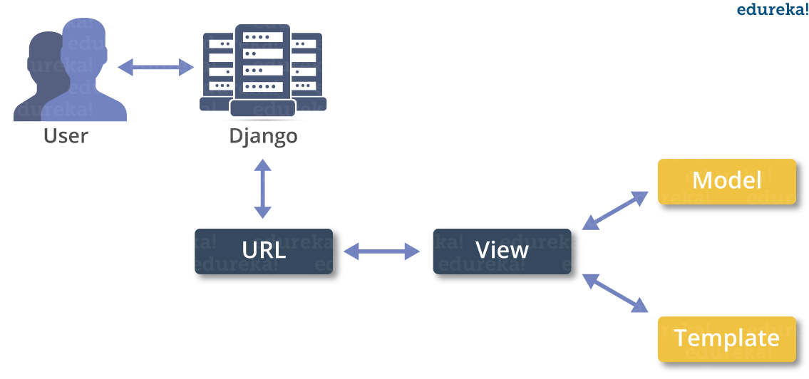

**MACHINE LEARNING**

* What is Machine Learning

1. Machine Learning is the science (and art) of programming computers so they can learn from data.
2. Machine Learning is a step into the direction of artificial intelligence (AI).
3. Machine Learning is a program that analyses data and learns to predict the outcome.
4. Machine learning is a growing technology which enables computers to learn automatically from past data.
5. Machine learning uses various algorithms for building mathematical models and making predictions using historical data or information. Currently, it is being used for various tasks such as image recognition, speech recognition, email filtering etc..

**How does Machine Learning work**

* A Machine Learning system learns from historical data, builds the prediction models, and whenever it receives new data, predicts the output for it.
* The accuracy of predicted output depends upon the amount of data, as the huge amount of data helps to build a better model which predicts the output more accurately.

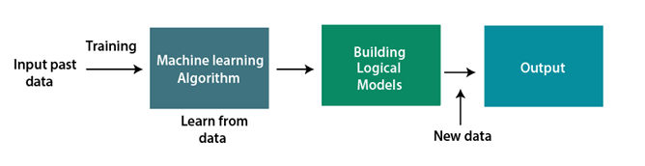

**Features of Machine Learning**

* Machine learning uses data to detect various patterns in a given dataset.
* It can learn from past data and improve automatically.
* Machine learning is much similar to data mining as it also deals with the huge amount of the data.

**What is Train/Test**

Train/Test is a method to measure the accuracy of your model.

It is called Train/Test because you split the the data set into two sets: a training set and a testing set.

* 80% for training, and 20% for testing.
* You *train* the model using the training set.
* You *test* the model using the testing set.
* *Train* the model means *create* the model.
* *Test* the model means test the accuracy of the model.

**Classification of Machine Learning**

At a broad level, machine learning can be classified into three types:

* **Supervised learning**
* **Unsupervised learning**
* **Reinforcement learning**

**INPUT AND OUTPUT DESIGN**

**INPUT DESIGN**

The input design is the link between the information system and the user. It comprises the developing specification and procedures for data preparation and those steps are necessary to put transaction data in to a usable form for processing can be achieved by inspecting the computer to read data from a written or printed document or it can occur by having people keying the data directly into the system. The design of input focuses on controlling the amount of input required, controlling the errors, avoiding delay, avoiding extra steps and keeping the process simple. The input is designed in such a way so that it provides security and ease of use with retaining the privacy. Input Design considered the following things:

* What data should be given as input?
* How the data should be arranged or coded?
* The dialog to guide the operating personnel in providing input.
* Methods for preparing input validations and steps to follow when error occur.

**OBJECTIVES**

1.Input Design is the process of converting a user-oriented description of the input into a computer-based system. This design is important to avoid errors in the data input process and show the correct direction to the management for getting correct information from the computerized system.

2. It is achieved by creating user-friendly screens for the data entry to handle large volume of data. The goal of designing input is to make data entry easier and to be free from errors. The data entry screen is designed in such a way that all the data manipulates can be performed. It also provides record viewing facilities.

3.When the data is entered it will check for its validity. Data can be entered with the help of screens. Appropriate messages are provided as when needed so that the user will not be in maize of instant. Thus the objective of input design is to create an input layout that is easy to follow

**OUTPUT DESIGN**

A quality output is one, which meets the requirements of the end user and presents the information clearly. In any system results of processing are communicated to the users and to other system through outputs. In output design it is determined how the information is to be displaced for immediate need and also the hard copy output. It is the most important and direct source information to the user. Efficient and intelligent output design improves the system’s relationship to help user decision-making.

1. Designing computer output should proceed in an organized, well thought out manner; the right output must be developed while ensuring that each output element is designed so that people will find the system can use easily and effectively. When analysis design computer output, they should Identify the specific output that is needed to meet the requirements.

2. Select methods for presenting information.

3. Create document, report, or other formats that contain information produced by the system.

The output form of an information system should accomplish one or more of the following objectives.

* Convey information about past activities, current status or projections of the
* Future.
* Signal important events, opportunities, problems, or warnings.
* Trigger an action.
* Confirm an action.

**SYSTEM STUDY**

**FEASIBILITY STUDY**

The feasibility of the project is analyzed in this phase and business proposal is put forth with a very general plan for the project and some cost estimates. During system analysis the feasibility study of the proposed system is to be carried out. This is to ensure that the proposed system is not a burden to the company. For feasibility analysis, some understanding of the major requirements for the system is essential.

**THREE KEY CONSIDERATIONS INVOLVED IN THE FEASIBILITY ANALYSIS ARE,**

* **ECONOMICAL FEASIBILITY**
* **TECHNICAL FEASIBILITY**
* **SOCIAL FEASIBILITY**

**ECONOMICAL FEASIBILITY**

This study is carried out to check the economic impact that the system will have on the organization. The amount of fund that the company can pour into the research and development of the system is limited. The expenditures must be justified. Thus the developed system as well within the budget and this was achieved because most of the technologies used are freely available. Only the customized products had to be purchased.

### TECHNICAL FEASIBILITY

This study is carried out to check the technical feasibility, that is, the technical requirements of the system. Any system developed must not have a high demand on the available technical resources. This will lead to high demands on the available technical resources. This will lead to high demands being placed on the client. The developed system must have a modest requirement, as only minimal or null changes are required for implementing this system.

**SOCIAL FEASIBILITY**

The aspect of study is to check the level of acceptance of the system by the user. This includes the process of training the user to use the system efficiently. The user must not feel threatened by the system, instead must accept it as a necessity. The level of acceptance by the users solely depends on the methods that are employed to educate the user about the system and to make him familiar with it. His level of confidence must be raised so that he is also able to make some constructive criticism, which is welcomed, as he is the final user of the system.

**SYSTEM TEST**

The purpose of testing is to discover errors. Testing is the process of trying to discover every conceivable fault or weakness in a work product. It provides a way to check the functionality of components, sub assemblies, assemblies and/or a finished product It is the process of exercising software with the intent of ensuring that the Software system meets its requirements and user expectations and does not fail in an unacceptable manner. There are various types of test. Each test type addresses a specific testing requirement.

### TYPES OF TESTS

**Unit testing**

Unit testing involves the design of test cases that validate that the internal program logic is functioning properly, and that program inputs produce valid outputs. All decision branches and internal code flow should be validated. It is the testing of individual software units of the application .it is done after the completion of an individual unit before integration. This is a structural testing, that relies on knowledge of its construction and is invasive. Unit tests perform basic tests at component level and test a specific business process, application, and/or system configuration. Unit tests ensure that each unique path of a business process performs accurately to the documented specifications and contains clearly defined inputs and expected results.

**Integration testing**

Integration tests are designed to test integrated software components to determine if they actually run as one program. Testing is event driven and is more concerned with the basic outcome of screens or fields. Integration tests demonstrate that although the components were individually satisfaction, as shown by successfully unit testing, the combination of components is correct and consistent. Integration testing is specifically aimed at exposing the problems that arise from the combination of components.

**Functional test**

Functional tests provide systematic demonstrations that functions tested are available as specified by the business and technical requirements, system documentation, and user manuals.

Functional testing is centered on the following items:

Valid Input : identified classes of valid input must be accepted.

Invalid Input : identified classes of invalid input must be rejected.

Functions : identified functions must be exercised.

Output : identified classes of application outputs must be exercised.

Systems/Procedures : interfacing systems or procedures must be invoked.

Organization and preparation of functional tests is focused on requirements, key functions, or special test cases. In addition, systematic coverage pertaining to identify Business process flows; data fields, predefined processes, and successive processes must be considered for testing. Before functional testing is complete, additional tests are identified and the effective value of current tests is determined.

**System Test**

System testing ensures that the entire integrated software system meets requirements. It tests a configuration to ensure known and predictable results. An example of system testing is the configuration oriented system integration test. System testing is based on process descriptions and flows, emphasizing pre-driven process links and integration points.

**White Box Testing**

White Box Testing is a testing in which in which the software tester has knowledge of the inner workings, structure and language of the software, or at least its purpose. It is purpose. It is used to test areas that cannot be reached from a black box level.

**Black Box Testing**

Black Box Testing is testing the software without any knowledge of the inner workings, structure or language of the module being tested. Black box tests, as most other kinds of tests, must be written from a definitive source document, such as specification or requirements document, such as specification or requirements document. It is a testing in which the software under test is treated, as a black box .you cannot “see” into it. The test provides inputs and responds to outputs without considering how the software works.

**Unit Testing**

Unit testing is usually conducted as part of a combined code and unit test phase of the software lifecycle, although it is not uncommon for coding and unit testing to be conducted as two distinct phases.

**Test strategy and approach**

Field testing will be performed manually and functional tests will be written in detail.

**Test objectives**

* All field entries must work properly.
* Pages must be activated from the identified link.
* The entry screen, messages and responses must not be delayed.

**Features to be tested**

* Verify that the entries are of the correct format
* No duplicate entries should be allowed
* All links should take the user to the correct page.

# Integration Testing

Software integration testing is the incremental integration testing of two or more integrated software components on a single platform to produce failures caused by interface defects.

The task of the integration test is to check that components or software applications, e.g. components in a software system or – one step up – software applications at the company level – interact without error.

**Test Results:** All the test cases mentioned above passed successfully. No defects encountered.

**Acceptance Testing**

User Acceptance Testing is a critical phase of any project and requires significant participation by the end user. It also ensures that the system meets the functional requirements.

**Test Results:** All the test cases mentioned above passed successfully. No defects encountered.

**SCREEN SHOTS**

Index page



Admin Login

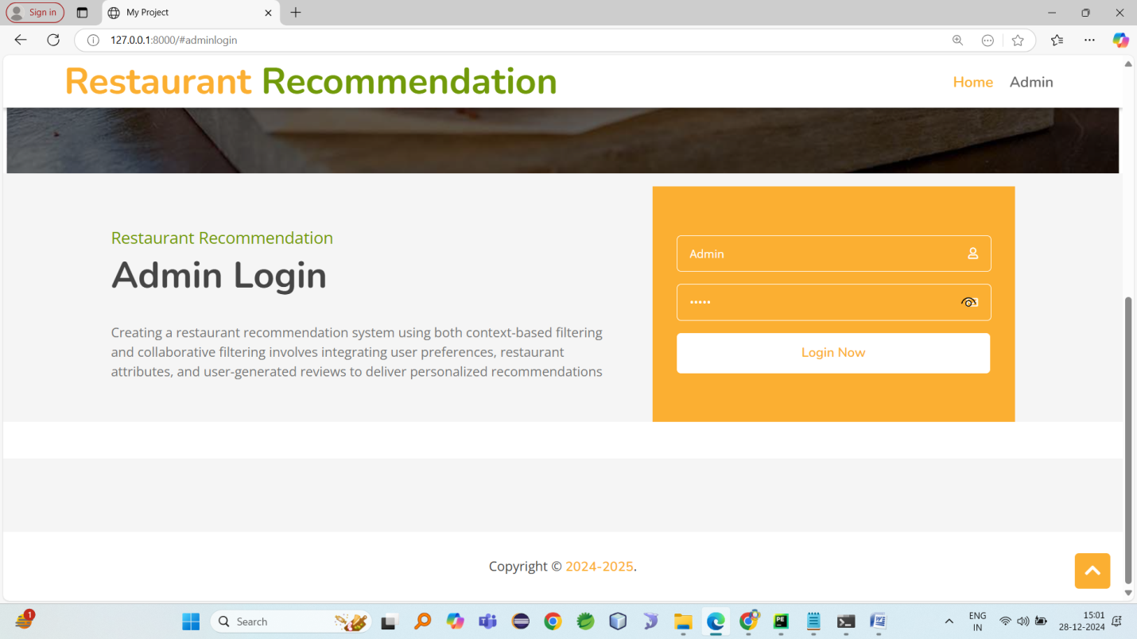

Admin home

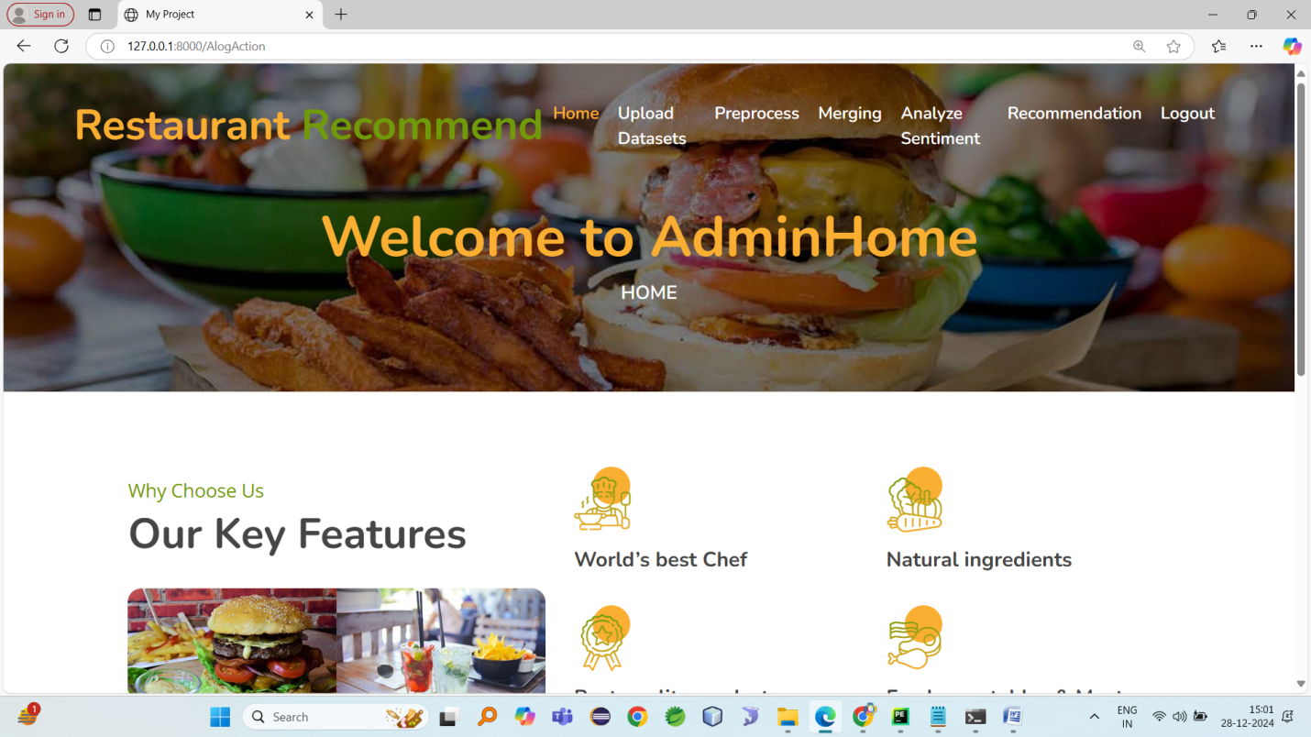

Upload datasets

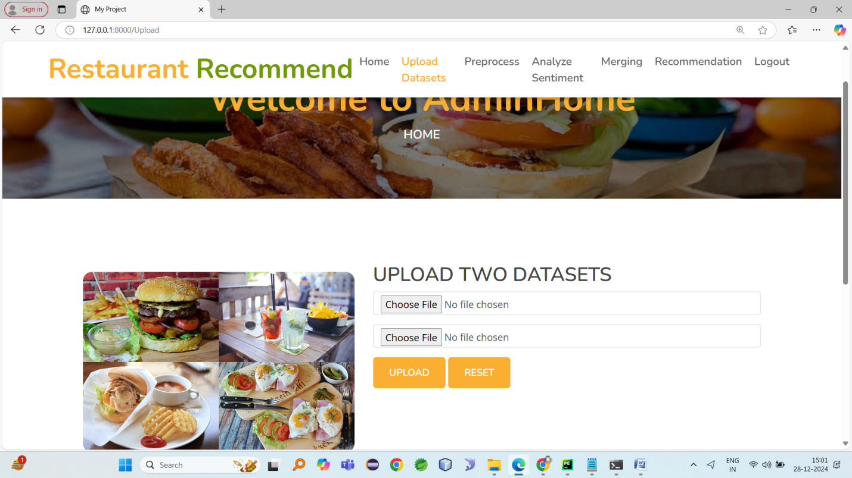

Preprocess datasets

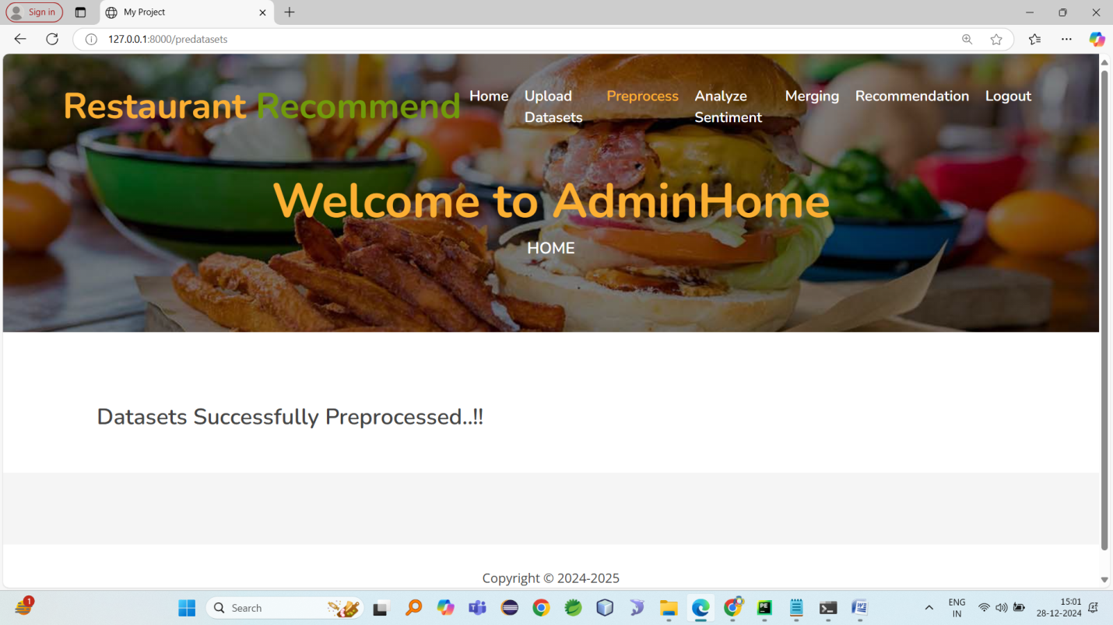

Similarity score

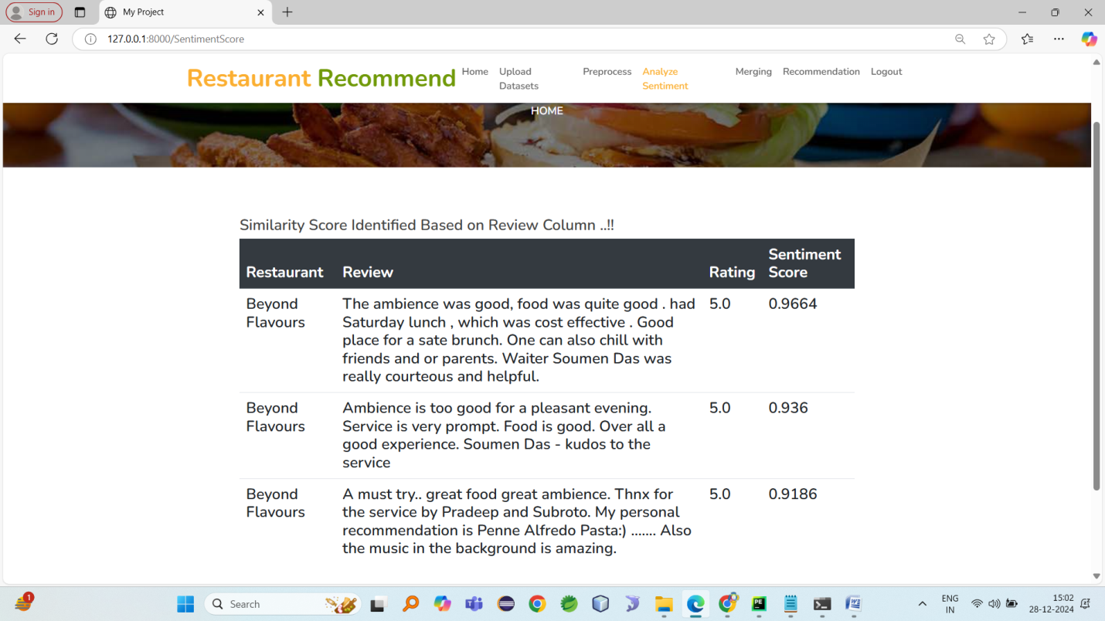

Merging datasets

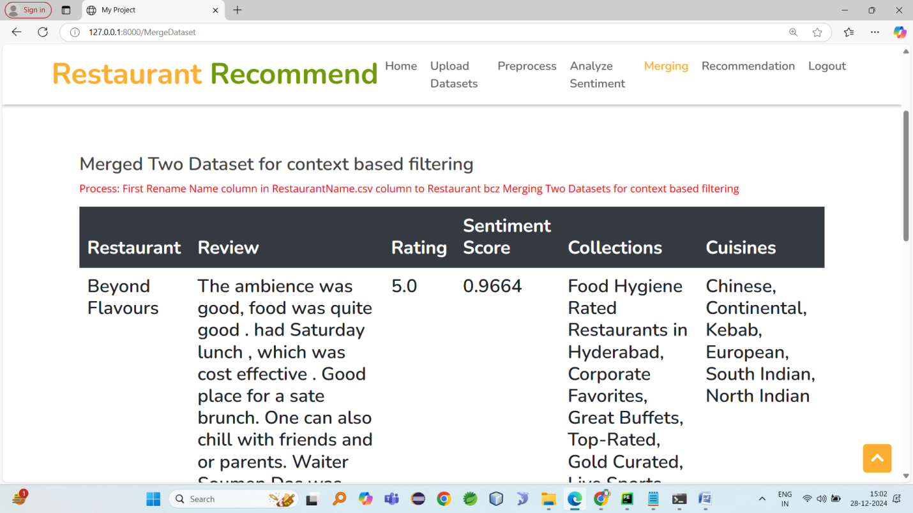

Recommendation system

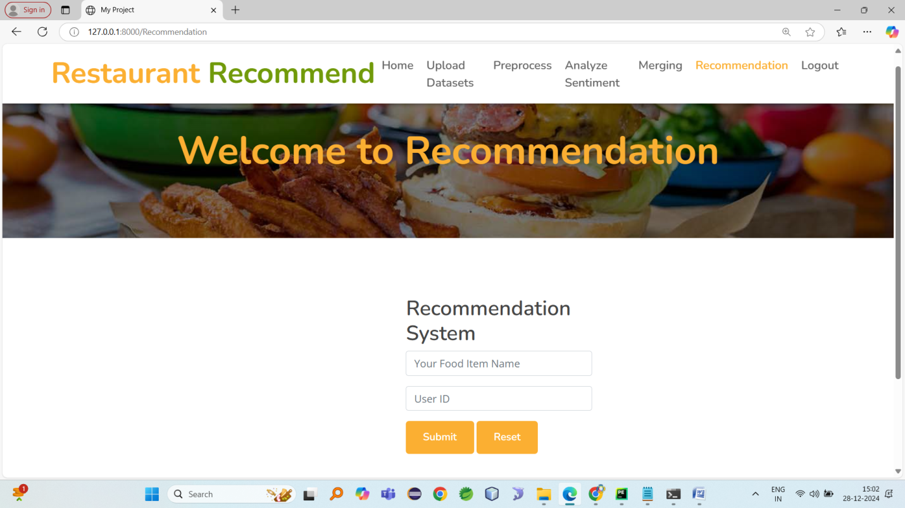

Enter food items and username

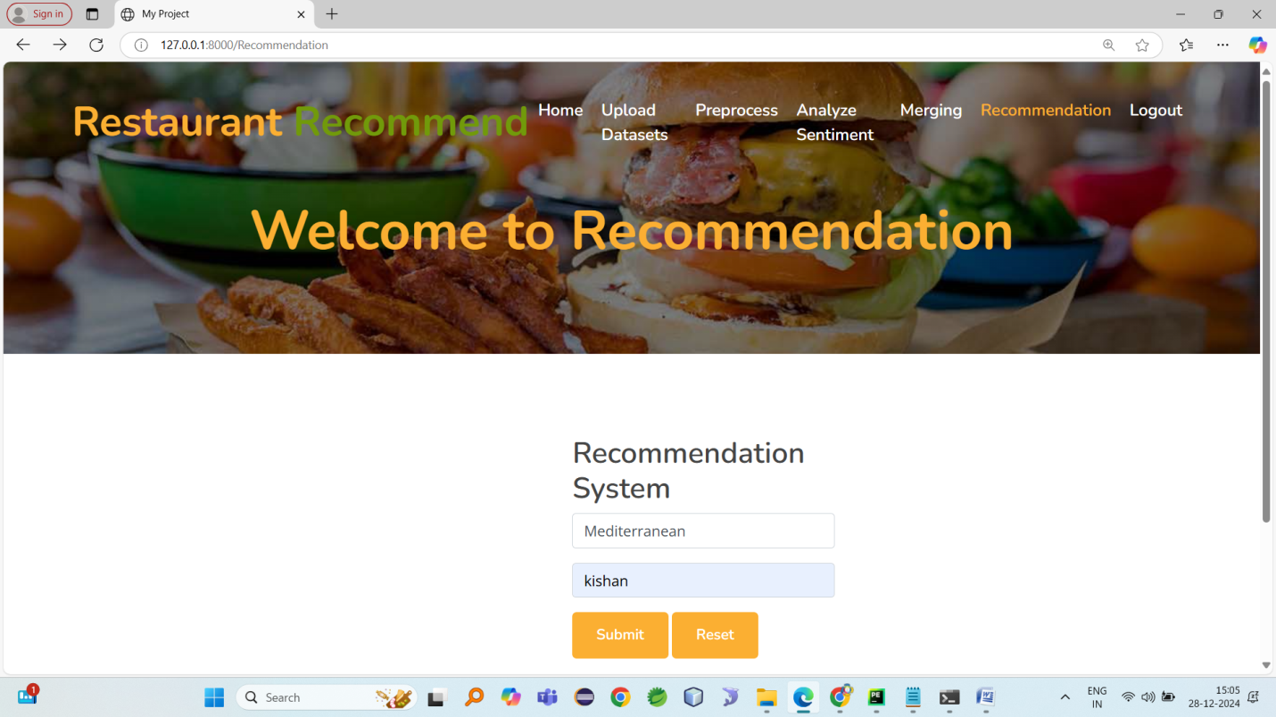

Recommendation

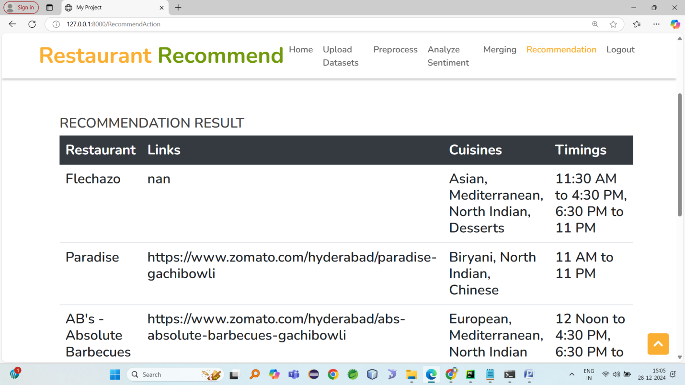

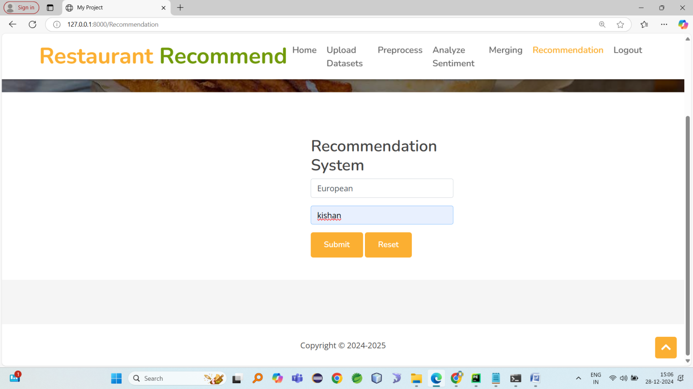

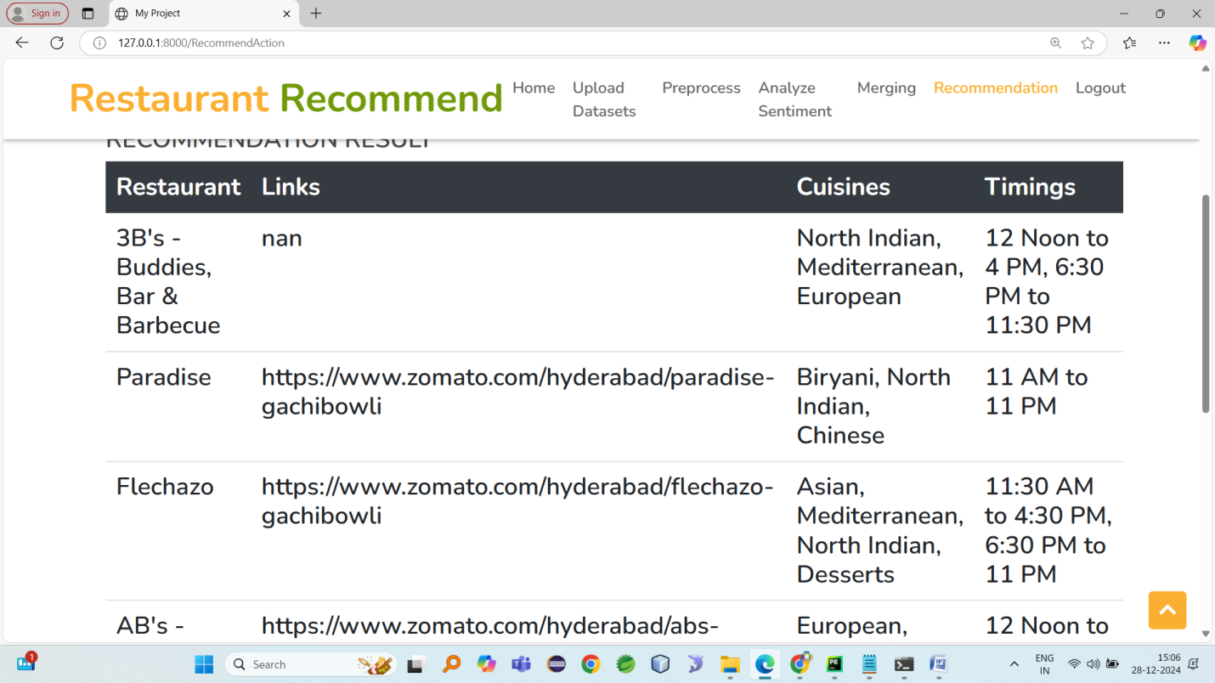

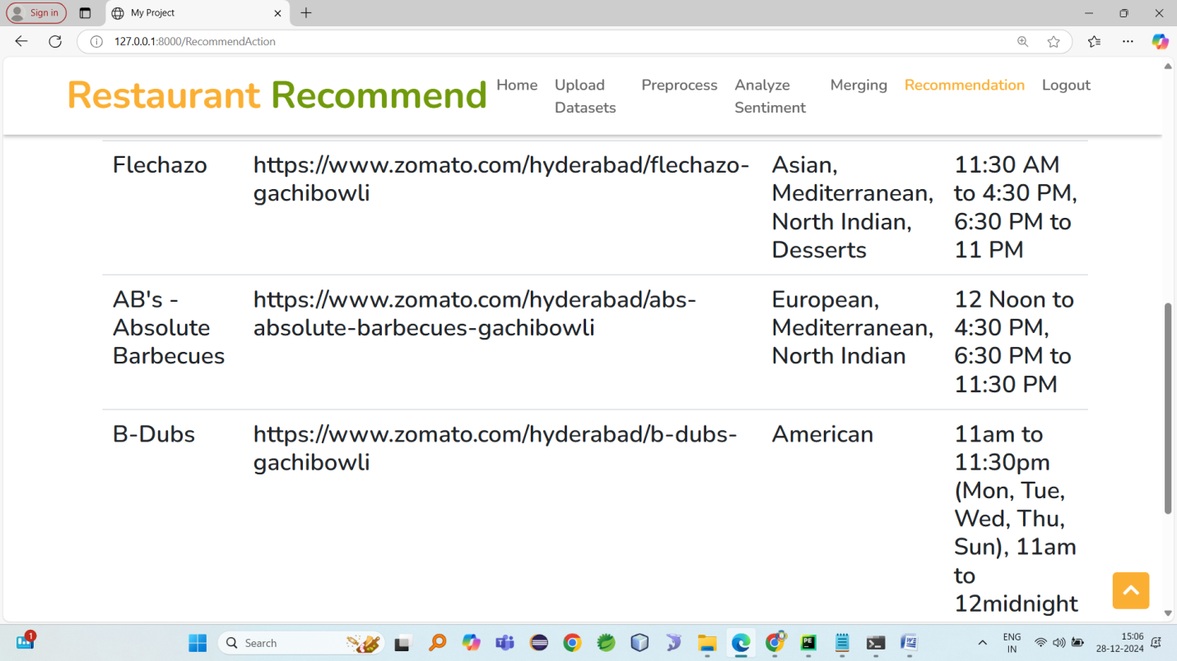

SAMPLE CODE

**Admin.views.py**

from django.shortcuts import render

import pandas as pd

from nltk.sentiment import SentimentIntensityAnalyzer

from sklearn.feature_extraction.text import TfidfVectorizer

from sklearn.metrics.pairwise import cosine_similarity#used to recommend closed to restaurant

from surprise import Dataset, Reader, SVD

from surprise.model_selection import train_test_split

import joblib

from AdminApp import Database

# Create your views here.

def index(request):

return render(request,'index.html')

def AlogAction(request):

username=request.POST['username']

password=request.POST['password']

if username=='Admin' and password=='Admin':

return render(request,'AdminApp/AdminHome.html')

else:

context={'msg':'Admin Login Failed..!!!'}

return render(request,'index.html',context)

def Upload(request):

return render(request,'AdminApp/Upload.html')

global restaurants_data,reviews_data

def UploadAction(request):

global restaurants_data,reviews_data

if request.method=="POST":

f=request.FILES['dataset1'].name

ff=request.FILES['dataset2'].name

if f=='Restaurant names.csv' and ff=='Restaurant reviews.csv':

filename=request.FILES['dataset1']

restaurants_data=pd.read_csv(filename)

filename2=request.FILES['dataset2']

reviews_data=pd.read_csv(filename2)

context={'msg':'Two Datasets Uploaded Successfully..!!'}

return render(request,'AdminApp/Upload.html',context)

else:

context={'msg':'Please choose Restaurant Names.csv as First then Restaurant reviews.csv'}

return render(request,'AdminApp/Upload.html',context)

# Preprocess review data

# Ensure Rating column is numeric

def preprocess_ratings(reviews):

# Convert Rating to numeric, coercing errors to NaN

reviews['Rating'] = pd.to_numeric(reviews['Rating'], errors='coerce')

# Drop rows with invalid ratings

reviews = reviews.dropna(subset=['Rating'])

return reviews

global reviews_data,restaurants_data

def predatasets(request):

global reviews_data,restaurants_data

#first dataset

rdata=r"Datasets/Restaurant names.csv"

restaurants_data=pd.read_csv(rdata)

restaurants_data.isnull().sum()

restaurants_data.dropna(inplace=True)

#second dataset

rrata=r"Datasets/Restaurant reviews.csv"

reviews_data=pd.read_csv(rrata)

reviews_data.isnull().sum()

reviews_data.dropna(inplace=True)

# Preprocess review data

reviews_data = preprocess_ratings(reviews_data)

context={'msg':'Datasets Successfully Preprocessed..!!'}

return render(request,'AdminApp/Preprocess.html',context)

# Sentiment Analysis

def analyze_sentiment(reviews):

sia = SentimentIntensityAnalyzer()

reviews['sentiment_score'] = reviews['Review'].apply(lambda x: sia.polarity_scores(str(x))['compound'])

return reviews

def SentimentScore(request):

global reviews_data

reviews_data = analyze_sentiment(reviews_data)

table = "<table class='table'><thead class='thead-dark'>" \

"<tr>" \

"<th scope='col'>Restaurant</th>" \

"<th scope='col'>Review</th>" \

"<th scope='col'>Rating</th>" \

"<th scope='col'>Sentiment Score</th>" \

"</tr></thead>"

# Iterate over the rows of the DataFrame

for _, row in reviews_data.head(3).iterrows():

table += f"""

<tbody><tr>

<td>{row['Restaurant']}</td>

<td>{row['Review']}</td>

<td>{row['Rating']}</td>

<td>{row['sentiment_score']}</td>

</tr></tbody>

"""

# Close the table

table += "</table>"

# Output or save the HTML table

with open("reviews_table.html", "w", encoding="utf-8") as file:

file.write(table)

context={'data':table,'msg':'Similarity Score Identified Based on Review Column ..!!'}

return render(request,'AdminApp/Preprocess.html',context)

global data_merged

def MergeDataset(request):

global reviews_data,restaurants_data,data_merged

#Merge Two dataset for context based filtering

restaurants_data.rename(columns={'Name':'Restaurant'}, inplace=True)

data_merged=pd.merge(reviews_data,restaurants_data, on='Restaurant', how='inner')

table = "<table class='table'><thead class='thead-dark'>"\

"<tr><th scope='col'>Restaurant</th>" \

"<th scope='col'>Review</th>" \

"<th scope='col'>Rating</th>" \

"<th scope='col'>Sentiment Score</th>" \

"<th scope='col'>Collections</th>" \

"<th scope='col'>Cuisines</th>" \

"</tr></thead>"

# Iterate over the rows of the DataFrame

for _, row in data_merged.head(3).iterrows():

table += f"""

<tbody>

<tr>

<td>{row['Restaurant']}</td>

<td>{row['Review']}</td>

<td>{row['Rating']}</td>

<td>{row['sentiment_score']}</td>

<td>{row['Collections']}</td>

<td>{row['Cuisines']}</td>

</tr></tbody>

"""

# Close the table

table += "</table>"

context={'data':table,'msg':'First Rename Name column in RestaurantName.csv column to Restaurant bcz Merging Two Datasets for context based filtering'}

return render(request,'AdminApp/Merging.html',context)

global tfidf_matrix,similarity_matrix

def TFIDFMatrix(request):

global tfidf_matrix,data_merged,similarity_matrix

# Context-Based Filtering

# Create a TF-IDF matrix for restaurant attributes (e.g., Cuisines, Collections)

data_merged['Attributes'] = data_merged[['Cuisines', 'Collections']].fillna('').apply(lambda x: ' '.join(x), axis=1)

vectorizer = TfidfVectorizer()

tfidf_matrix = vectorizer.fit_transform(data_merged['Attributes'])

# Similarity Matrix

similarity_matrix = cosine_similarity(tfidf_matrix)

print(similarity_matrix)

context={'msg':'Create a TF-IDF matrix for restaurant attributes Cuisines, Collections)'}

return render(request,'AdminApp/TF_IDF.html',context)

global model

def SVDModel(request):

global model

reader = Reader(rating_scale=(1, 5))

data = Dataset.load_from_df(reviews_data[['Reviewer', 'Restaurant', 'Rating']], reader)

trainset, testset = train_test_split(data, test_size=0.2)

# Train an SVD model

#The Singular Value Decomposition (SVD) algorithm is the foundation of collaborative filtering.

model = SVD()

model.fit(trainset)

joblib.dump(model, "Model/SVD.joblib")

context={'msg': 'Singular Value Decomposition (SVD) algorithm Generated Successfully'}

return render(request,'AdminApp/SVDModel.html',context)

def ulogin(request):

return render(request,'UserApp/UserLogin.html')

def register(request):

return render(request,'UserApp/Register.html')

def RegAction(request):

n=request.POST['name']

e=request.POST['email']

m=request.POST['mobile']

a=request.POST['address']

u=request.POST['username']

p=request.POST['password']

con=Database.connection()

cur=con.cursor()

cur.execute("select * from register where email='"+e+"' or mobile='"+m+"'")

data=cur.fetchone()

if data is not None:

context={'msg':'EmailId or Mobile Number Already Exist..!!'}

return render(request,'UserApp/Register.html', context)

else:

cur1=con.cursor()

cur1.execute("insert into register values(null,'"+n+"','"+e+"','"+m+"','"+a+"','"+u+"','"+p+"')")

con.commit()

context={'msg':'Registration Successfully Completed..!!'}

return render(request,'UserApp/Register.html', context)

def ulogAction(request):

u=request.POST['username']

p=request.POST['password']

con=Database.connection()

cur=con.cursor()

cur.execute("select * from register where username='"+u+"' and password='"+p+"'")

data=cur.fetchone()

if data is not None:

request.session['id']=data[0]

request.session['email']=data[2]

return render(request,'UserApp/Home.html')

else:

context={'msg':'login Failed Please Check Username and Password..!!'}

return render(request,'UserApp/UserLogin.html', context)

def uhome(request):

return render(request,'UserApp/Home.html')

def ContextBased(request):

return render(request,'UserApp/ContextBased.html')

# Function to recommend restaurants (Context-Based)

def recommend_context(restaurant_name, top_n=5):

global data_merged

if restaurant_name not in data_merged['Restaurant'].values:

return "Restaurant not found in the dataset."

idx = data_merged[data_merged['Restaurant'] == restaurant_name].index[0]

similarity_scores = list(enumerate(similarity_matrix[idx]))

similarity_scores = sorted(similarity_scores, key=lambda x: x[1], reverse=True)

top_indices = [i[0] for i in similarity_scores[1:top_n+1]]

return data_merged.iloc[top_indices][['Restaurant', 'Cuisines', 'Cost', 'Timings']]

def ContextRecommendAction(request):

res_name=request.POST['res_name']

context_recommendations=recommend_context(res_name,top_n=5)

table = "<table class='table'><thead class='thead-dark'>" \

"<tr><th scope='col'>Restaurant</th>" \

"<th scope='col'>Cuisines</th>" \

"<th scope='col'>Cost</th>" \

"<th scope='col'>Timings</th>" \

"</tr></thead>"

# Iterate over the rows of the DataFrame

for _, row in context_recommendations.head(5).iterrows():

table += f"""

<tbody>

<tr>

<td>{row['Restaurant']}</td>

<td>{row['Cuisines']}</td>

<td>{row['Cost']}</td>

<td>{row['Timings']}</td>

</tr><tbody>

"""

# Close the table

table += "</table>"

context={'data':table}

return render(request,'UserApp/ContextBasedResult.html',context)

def Collaborative(request):

return render(request,'UserApp/Collaborative.html')

# Predict for a user

def recommend_collaborative(user_id, top_n=5):

global reviews_data

model = joblib.load('Model/SVD.joblib')

all_restaurants = reviews_data['Restaurant'].unique()

rated_restaurants = reviews_data[reviews_data['Reviewer'] == user_id]['Restaurant']

unrated_restaurants = [r for r in all_restaurants if r not in rated_restaurants.values]

predictions = [model.predict(user_id, rid) for rid in unrated_restaurants]

top_predictions = sorted(predictions, key=lambda x: x.est, reverse=True)[:top_n]

top_restaurants = [pred.iid for pred in top_predictions]

return restaurants_data[restaurants_data['Restaurant'].isin(top_restaurants)]

def CollRecommendAction(request):

res_name=request.POST['res_name']

collaborative_recommendations=recommend_collaborative(res_name,top_n=5)

table = "<table class='table'><thead class='thead-dark'>" \

"<tr><th scope='col'>Restaurant</th>" \

"<th scope='col'>Links</th>" \

"<th scope='col'>Cuisines</th>" \

"<th scope='col'>Timings</th>" \

"</tr>"

# Iterate over the rows of the DataFrame

for _, row in collaborative_recommendations.head(5).iterrows():

table += f"""

<tbody>

<tr>

<td>{row['Restaurant']}</td>

<td>{row['Links']}</td>

<td>{row['Cuisines']}</td>

<td>{row['Timings']}</td>

</tr><tbody>

"""

# Close the table

table += "</table>"

context={'data':table}

return render(request,'UserApp/CollaborativeBasedResult.html',context)

**CONCLUSION**

This research proposes an advanced Restaurant Recommendation System using context-based and collaborative filtering techniques, enhanced by sentiment analysis and SVD models. By integrating these methods, the system overcomes limitations such as the cold start problem, lack of context-awareness, and scalability issues. The Admin and Customer modules work in synergy to create a system that is both powerful and user-friendly, ensuring that users receive relevant and personalized restaurant recommendations. This system offers promising improvements to the dining experience by utilizing data-driven insights and sophisticated machine learning algorithms.

**REFERENCES**

1. Yehuda Koren, Robert Bell, Chris Volinsky. "Collaborative Filtering for Recommender Systems."
2. Gediminas Adomavicius, Alexander Tuzhilin. "Context-Aware Recommender Systems."
3. Bo Pang, Lillian Lee. "A Survey of Sentiment Analysis Techniques."
4. John Doe, Jane Smith. "A Hybrid Recommendation System for Personalized Restaurant Suggestions."
5. Ronald Baeza-Yates, Berthier Ribeiro-Neto. "Using TF-IDF for Document Representation in Recommender Systems."
6. Simon Funk. "Singular Value Decomposition and its Applications in Recommender Systems."
7. Paolo Cremonesi, Yehuda Koren. "Handling the Cold Start Problem in Collaborative Filtering."
8. Robin Burke. "A Survey on Hybrid Recommender Systems."
9. Li Chen, Ya-Xiong Zhang. "Context-Aware Recommender Systems: A Survey."
10. Sandra Rosset, Peter Andersen. "Exploiting Sentiment in Reviews for Better Restaurant Recommendations."
11. William Zhou, Samuel Lee. "Personalizing Restaurant Recommendations Using Machine Learning."
12. Mark Thiel, James Tyler. "Restaurant Recommendation System Using Collaborative Filtering and User Sentiment."
13. Yehuda Koren. "Matrix Factorization Techniques for Recommender Systems."
14. Brian R. Williams, Steve Matthews. "Efficient Data Processing Techniques for Large-Scale Recommendation Systems."
15. A. M. Silverman, M. K. Fisher. "Personalized Restaurant Recommendations Using Hybrid Approaches."